Lab 2: Agile Backlog Creation & Sprint Simulation in Jira
Goal: Given a prewritten set of user stories (derived from Lab 1 requirements), create and prioritize an agile backlog in Jira; estimate story points; run a mini-sprint; and export a burndown chart.
Duration: 90 minutes
Group Size: Individual
Learning Outcomes:
By the end of this lab, students will be able to:
- Define and create Epics and User Stories in Jira using Agile conventions, ensuring clarity in functional requirements and end-user goals.
- Prioritize backlog items based on business value and user needs, and organize them in a structured Agile backlog.
- Assign Story Points to User Stories using the Fibonacci sequence to estimate effort, complexity, and uncertainty.
- Apply Planning Poker as a collaborative estimation technique to foster team alignment on task difficulty.
- Simulate a Sprint by creating Sprint 1 in Jira, populating it with selected backlog items, and progressing tasks across To Do → In Progress → Done.
- Monitor Sprint progress using Jira’s Burndown Chart to track work completion against planned velocity.
- Reflect on team performance and Agile workflow through group discussion and analysis of Sprint outcomes.

Lab 2 Steps
- Create Stories in Jira (20 min)
- Assign Story Points (25 min)
  - Planning Poker Introduction (5 min):
  - Team Discussion (20 min):
- Prioritize & Rank Backlog (15 min)
  - Set Priority for each story in Jira
  - Reorder Backlog
- Run a Mock Sprint (20 min)
  - Create Sprint 1
  - Simulate Progress
  - Add Comments
- Generate Burndown Chart.
- Group Reflection.

Epic 1: Customer Ordering Experience
Description: Enable customers to browse, customize, and place coffee orders through an intuitive self-service interface.
User Stories: | As a | I want to | So that
Story 1.1: Coffee Selection | As a customer | I want to browse and select from different coffee types (Espresso, Americano, Latte, Cappuccino) | So that I can choose my preferred beverage
Story 1.2: Size Selection | As a customer | I want to choose my drink size (Small, Medium, Large) | So that I can get the right portion for my needs
Story 1.3: Add-on Customization | As a customer | I want to add customizations like extra shots, alternative milk (Soy/Almond), and syrups | So that I can personalize my drink to my preferences
Story 1.4: Order Review | As a customer | I want to review my complete order before payment | So that I can confirm all details are correct
Epic 2: Payment Processing
Description: Provide secure and efficient payment processing for customer orders.
User Stories: | As a | I want to | So that
Story 2.1: Payment Method Selection | As a customer | I want to choose between credit/debit card or mobile wallet payment | So that I can pay using my preferred method
Story 2.2: Payment Processing | As a customer | I want to complete my payment securely and quickly | So that I can receive my order without delay
Epic 3: Order Completion and Receipt
Description: Provide order confirmation and loyalty program integration.
User Stories: | As a | I want to | So that
Story 3.1: Receipt Generation | As a customer | I want to receive a printed receipt with my order details | So that I have proof of purchase and order information
Story 3.2: Loyalty Points | As a customer | I want to earn loyalty points with my purchase | So that I can benefit from repeat visits
Epic 4: System Performance and Usability
Description: Ensure the kiosk operates efficiently and provides excellent user experience.
User Stories: | As a | I want to | So that
Story 4.1: Quick Order Completion | As a customer | I want to complete my entire order in under 60 seconds | So that I can get my coffee quickly during busy periods
Story 4.2: Intuitive Interface | As a customer | I want to use the kiosk without any external help or training | So that I can place my order confidently and independently
Epic 5: Administrative Management
Description: Enable café staff to manage the kiosk system effectively.
User Stories: | As a | I want to | So that
Story 5.1: Inventory Management | As a café administrator | I want to refill ingredients and update stock levels | So that the kiosk can continue serving customers without interruption
Story 5.2: Menu and Pricing Updates | As a café administrator | I want to update coffee prices and menu items | So that the kiosk reflects current offerings and pricing
Story 5.3: Sales Reporting | As a café administrator | I want to view sales reports and analytics | So that I can understand business performance and customer preferences
Epic 6: System Integration
Description: Ensure seamless integration with external systems and services.
User Stories: | As a | I want to | So that
Story 6.1: Payment Gateway Integration | As a system administrator | I want to integrate with reliable payment gateways | So that customer payments are processed securely and efficiently

Step-By-Step Solution: Coffee Kiosk SCRUM Board
- Log into your Jira account or open Jira account in your browser. 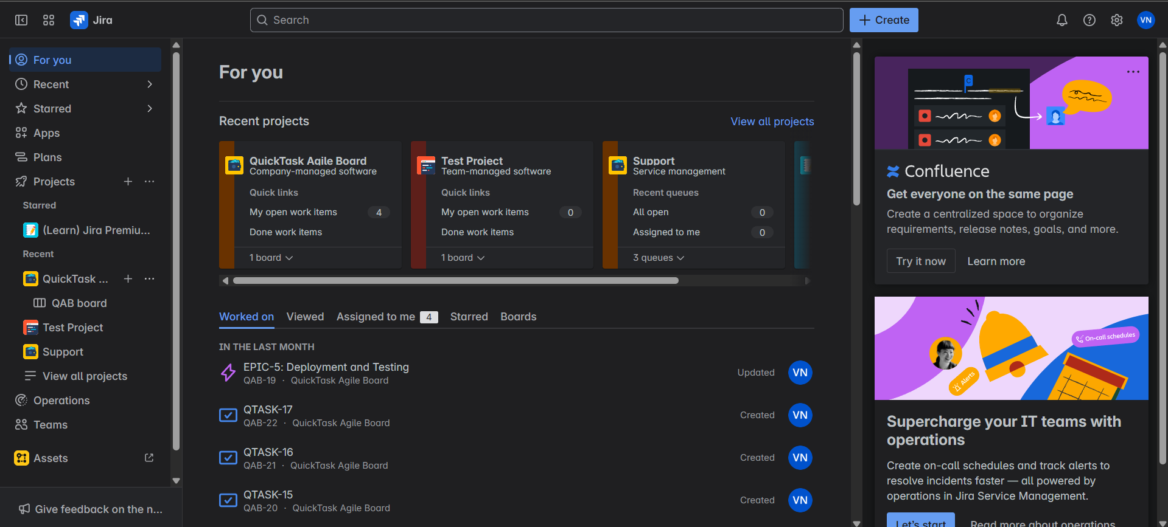

- Click on the “+” logo next to Projects. 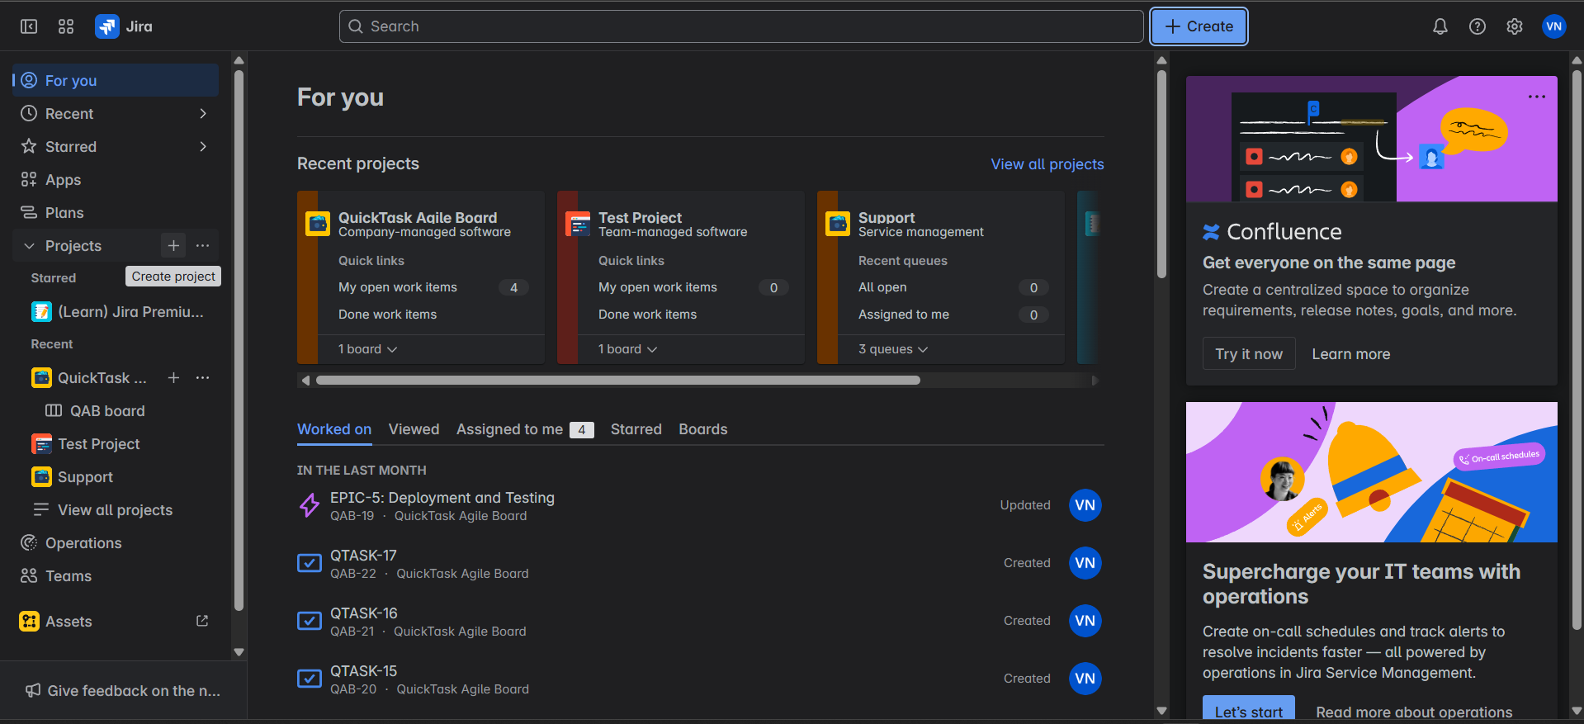

- Select Software Development and Choose SCRUM and use template. 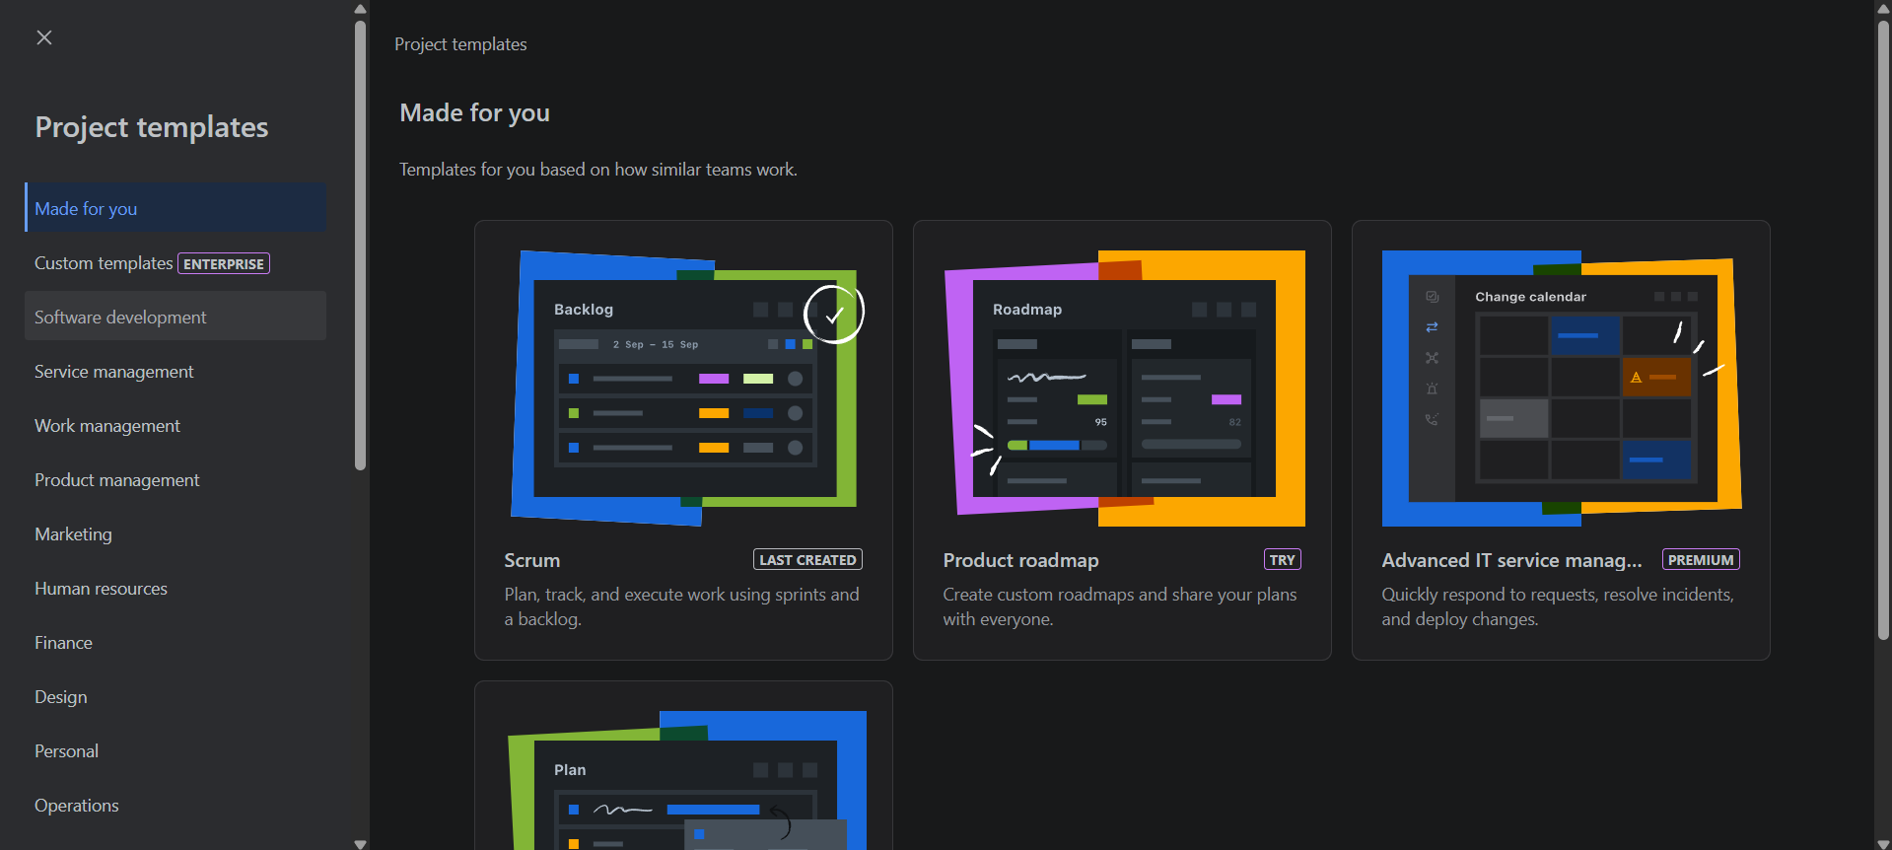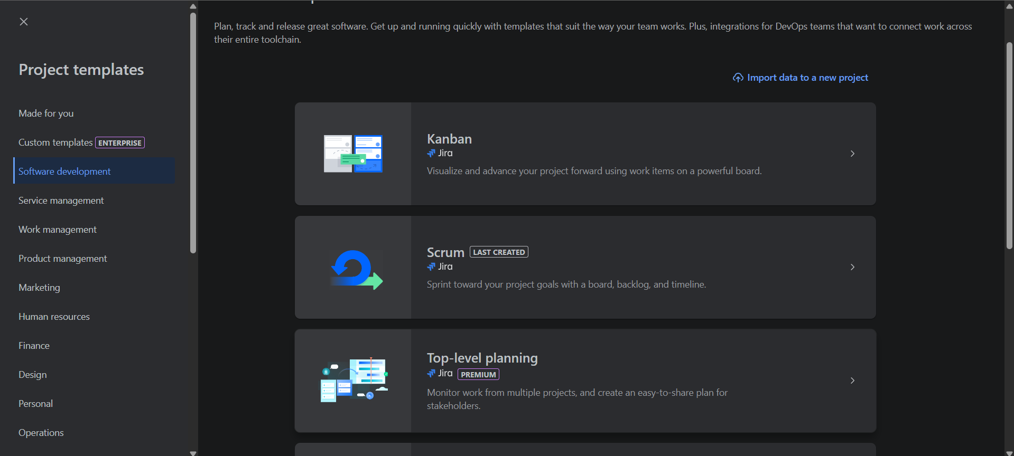

- Choose Company-managed Project Type. 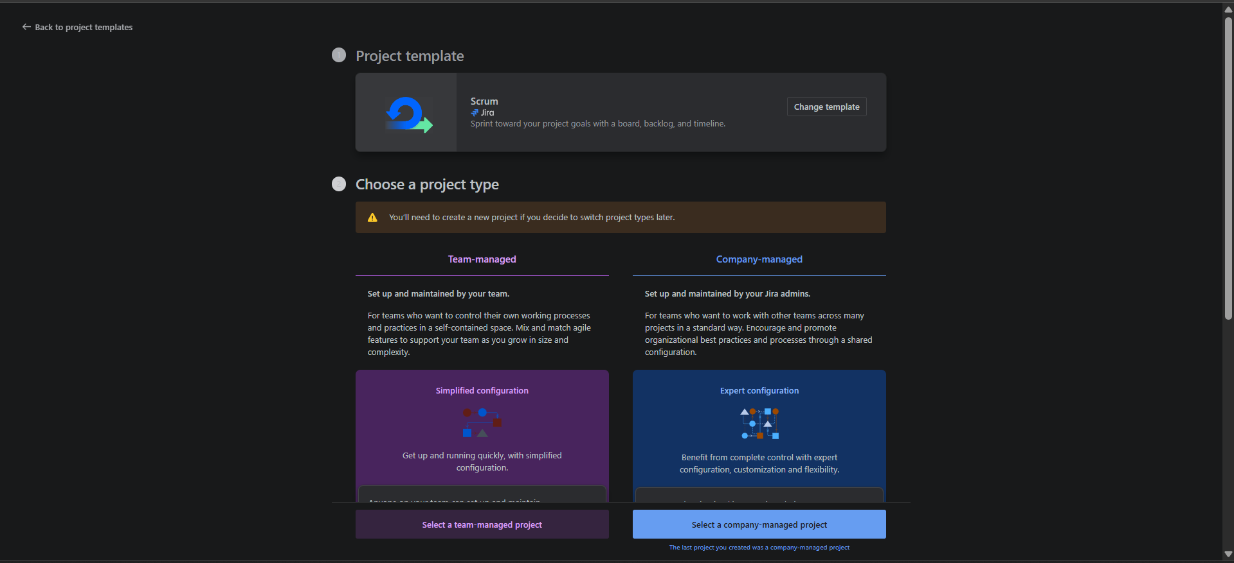

- Name your Project and click next. 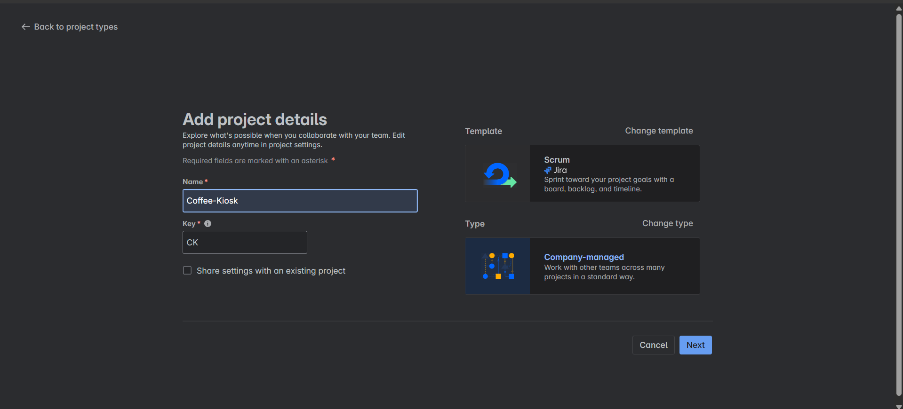

- Now you’ll see your SCRUM Board created in Jira. 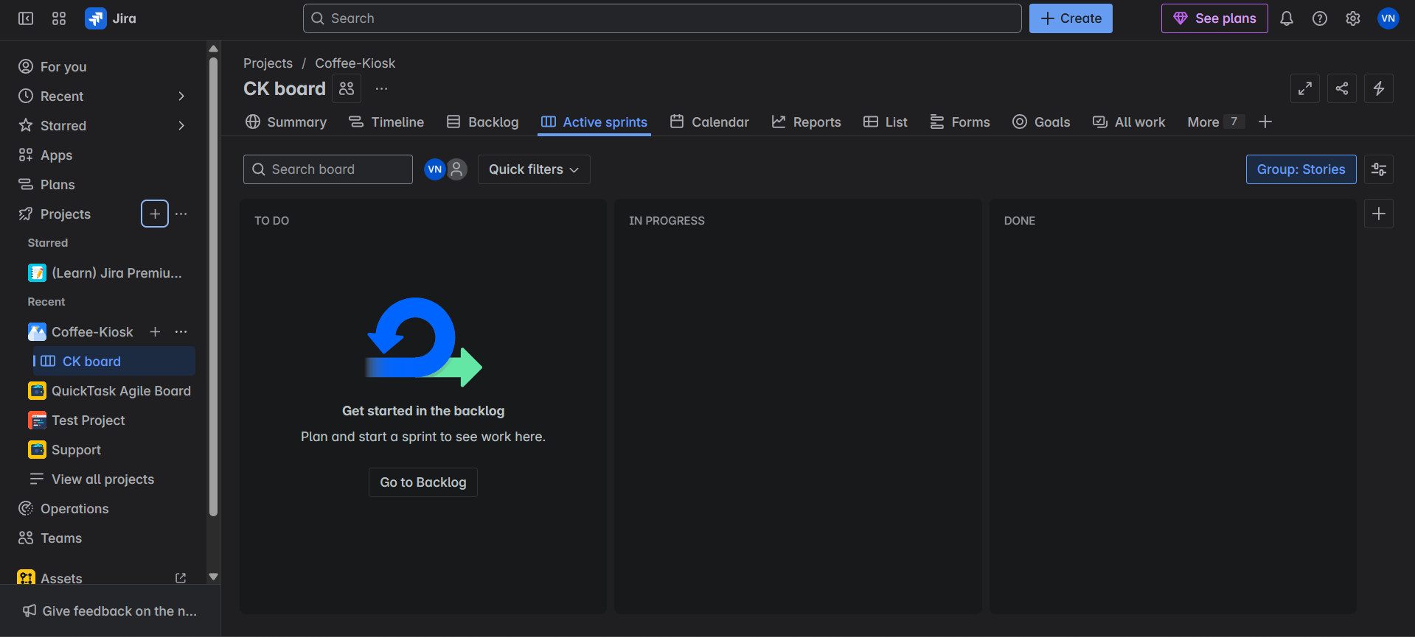

- Go to Backlogs, this is where you create Sprints, Epics, User Stories, Tasks and Subtasks. 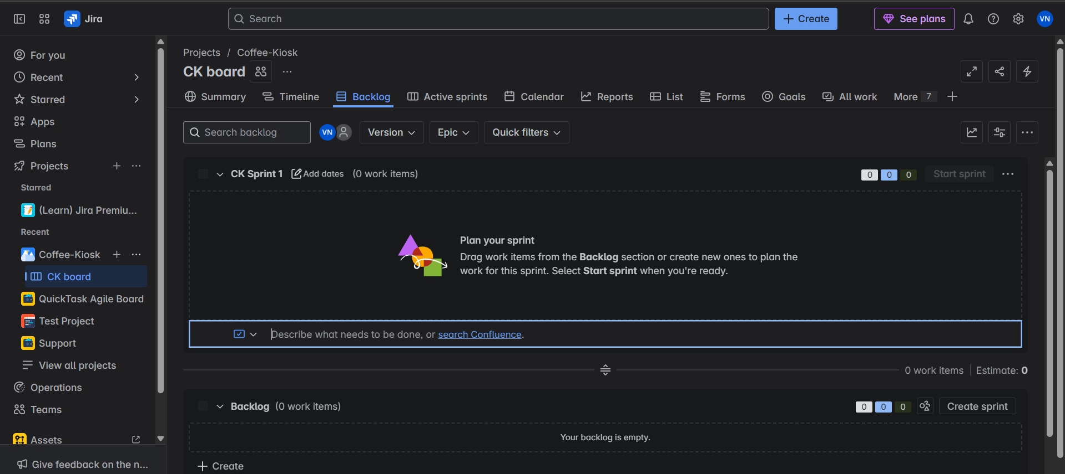

Now you’ll be creating Epics, what are Epics??
Epic:
An agile epic is a body of work that can be broken down into specific tasks (called user stories) based on the needs/requests of customers or end-users. Epics are an important practice for agile and DevOps teams.
Epic allows us to break down large complex tasks into small easier ones.
Example:
Epic 1: Customer Ordering Experience
Description: Enable customers to browse, customize, and place coffee orders through an intuitive self-service interface.

- Click on the blue Create button near the search bar, and choose Epic from the work type drop down, scroll down and in Summary name you Epic or you can say EPIC1 and add description (refer to the above example) for the Epic and click create to create your Epic. 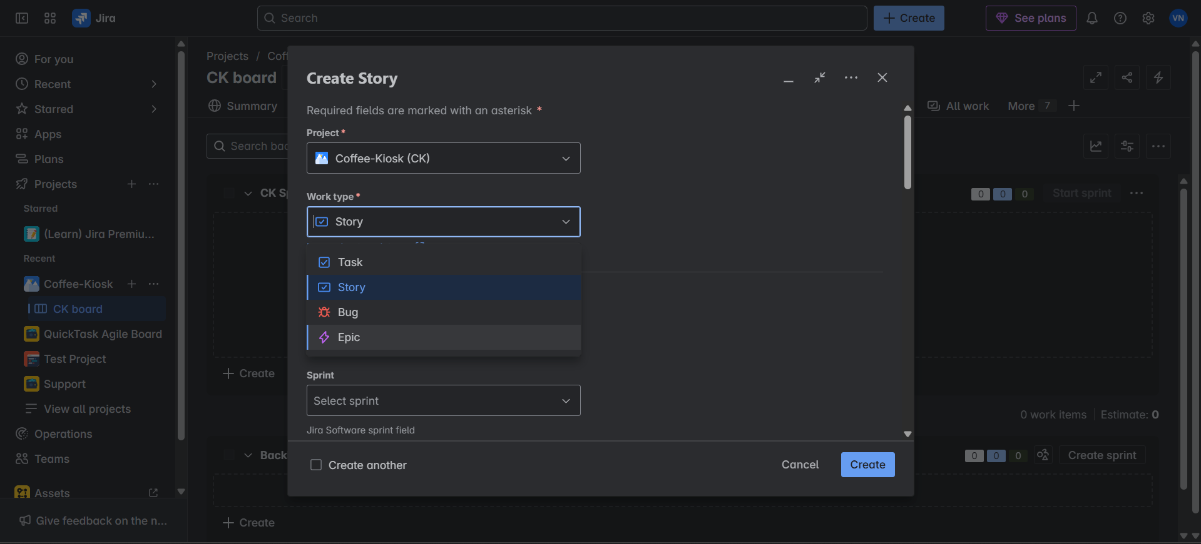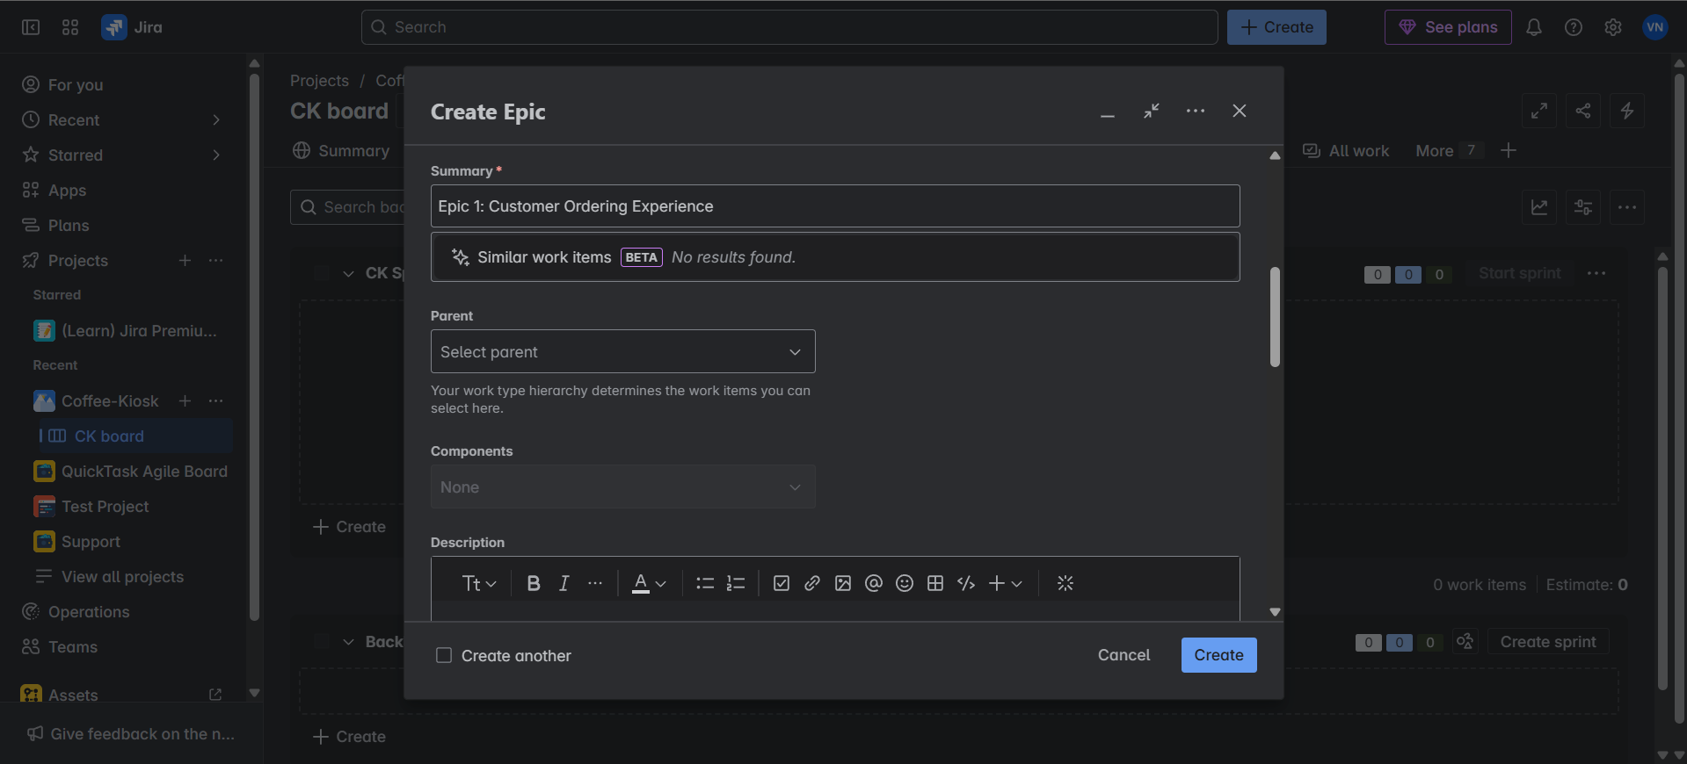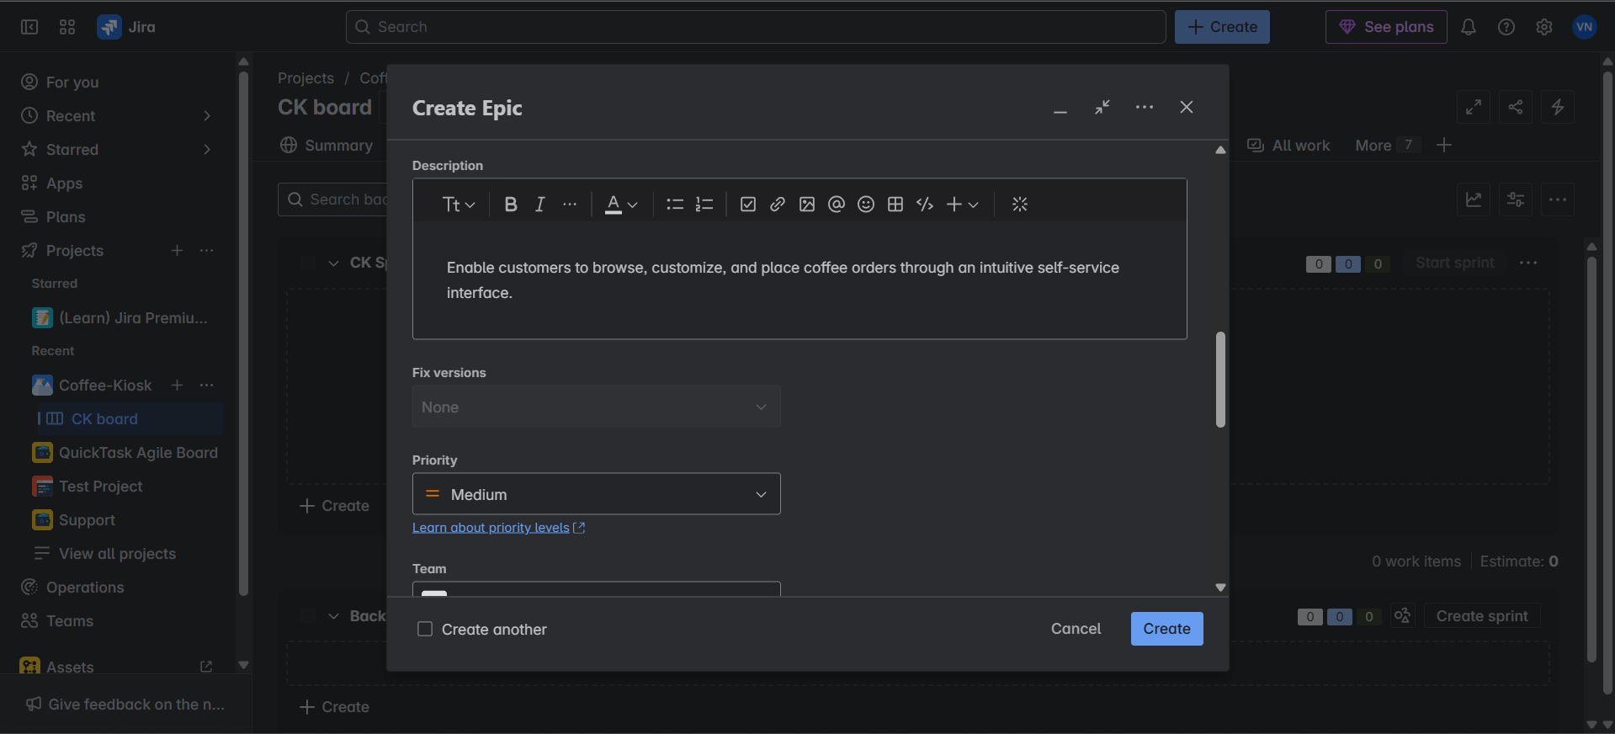

- Press “E” key on your keyboard or you can click on Epic that you see in the backlog panel board and enable show epic panel. 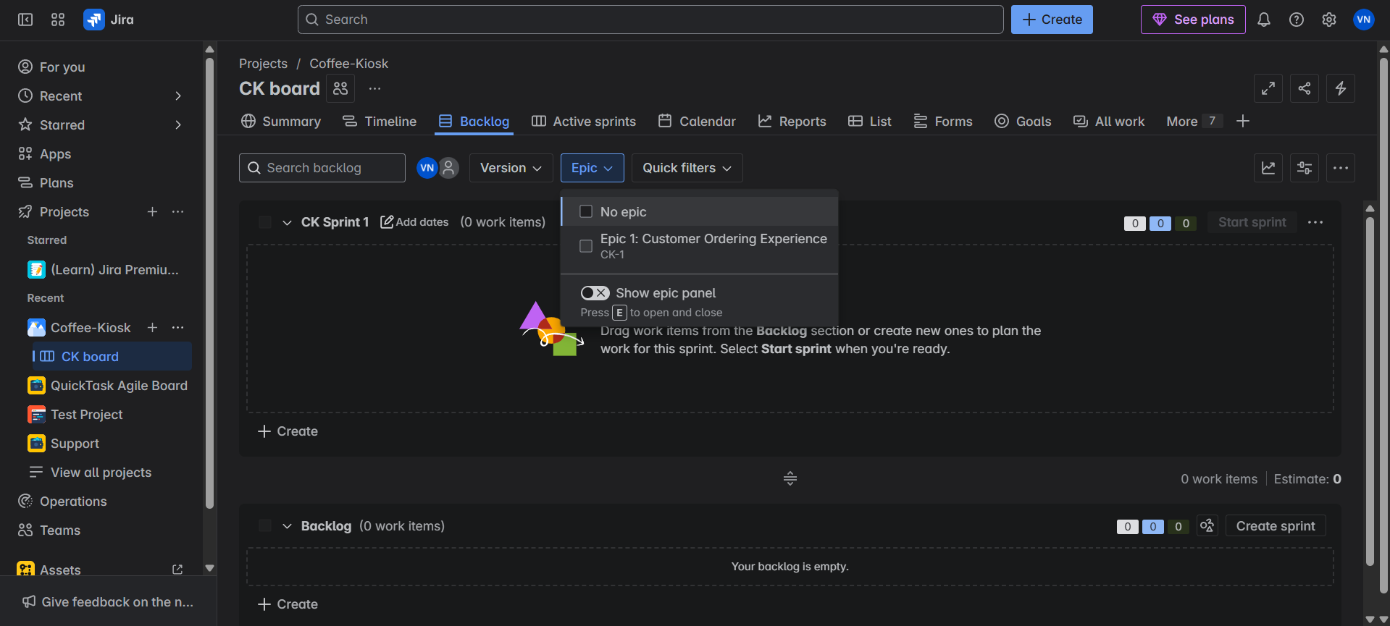

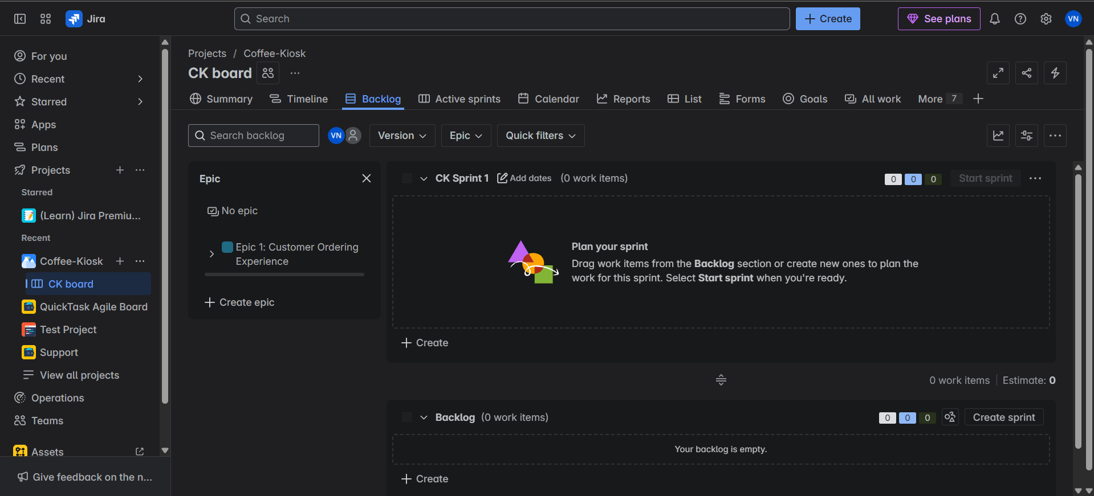
Create the necessary Epics before making User Stories for them. Once you’ve identified and made the necessary Epics with the Functional Requirements, create User Stories. What are User Stories??
User Stories:
A user story is an informal, general explanation of a software feature written from the perspective of the end user. Its purpose is to articulate how a software feature will provide value to the customer.
It's tempting to think that user stories are, simply put, software system requirements. But they're not.
User story gives us the perspective of the end-user or Customer.

Template:
As a [user role], I want [goal/desire] so that [benefit].

User Stories follow the above format. (e.g.: - As a: frequent app user, I want: to receive push notifications for important updates, so that: I can stay informed while on the go.

Example:
Story 1.1: Coffee Selection:
As a customer
I want to browse and select from different coffee types (Espresso, Americano, Latte, Cappuccino)
So that I can choose my preferred beverage

Story 1.2: Size Selection:
As a customer
I want to choose my drink size (Small, Medium, Large)
So that I can get the right portion for my needs

- Click on the arrow next to the Epic/Epic Name and you’ll see “View Details” and “Create work item”. 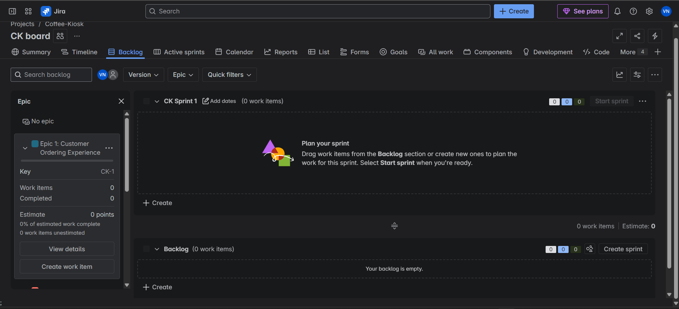
This is due to the new Jira development where the Work Items are User Stories, Tasks and Subtasks.
Click on “Create work item”, by default, it shows story, if not click on the drop down and choose work type as Story. 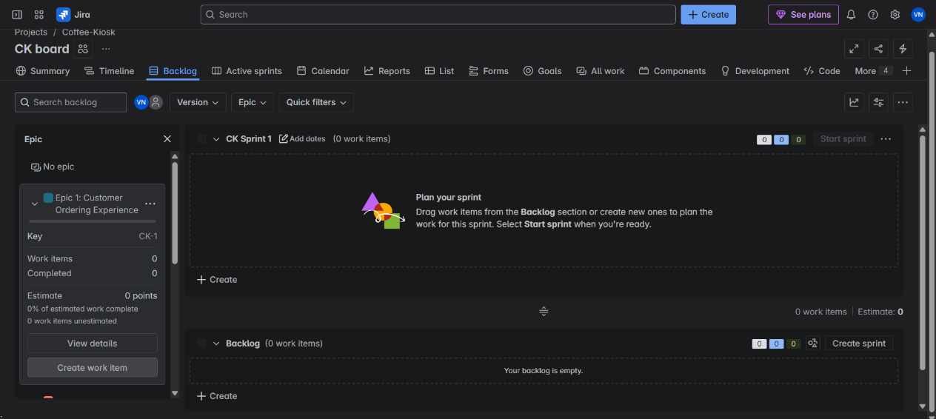
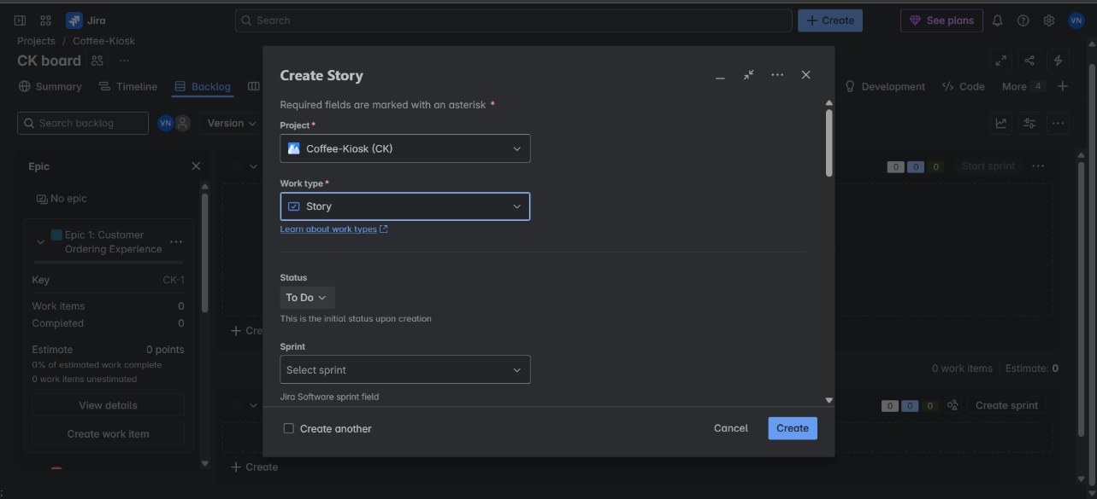

- Similar to Epic, add the User Story Title as summary and describe the User Story. 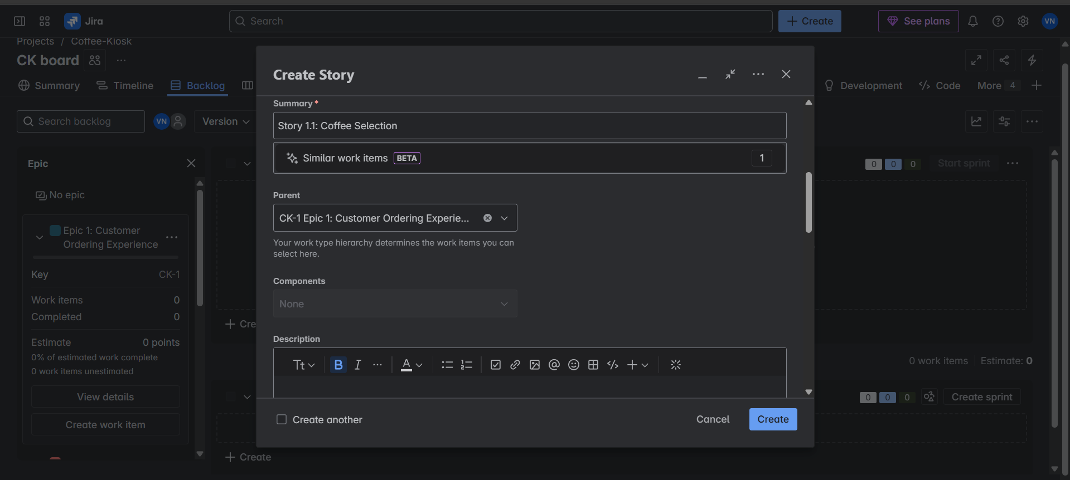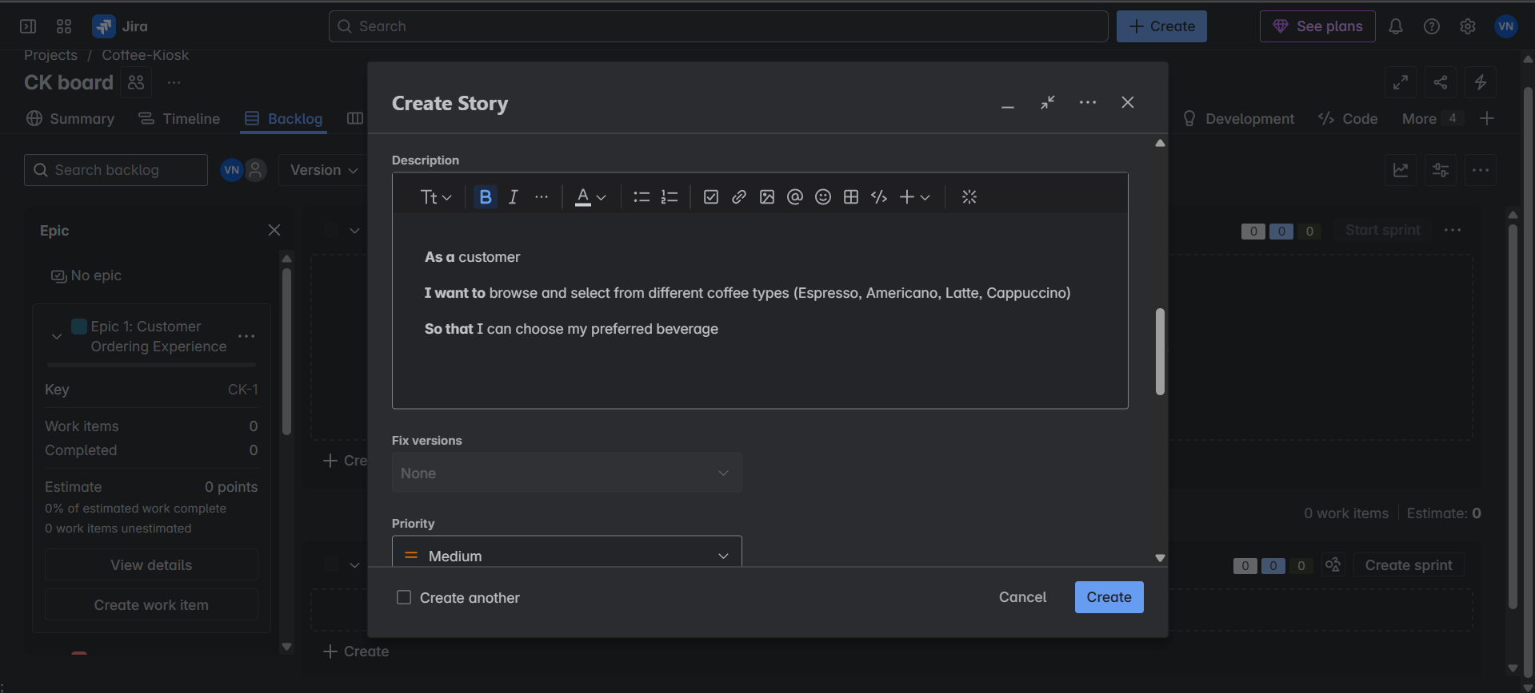

- Now you’ll see from the initial empty Backlog panel will now be populated and the change in Epic can be noticed. It shows a work item added to the Epic. 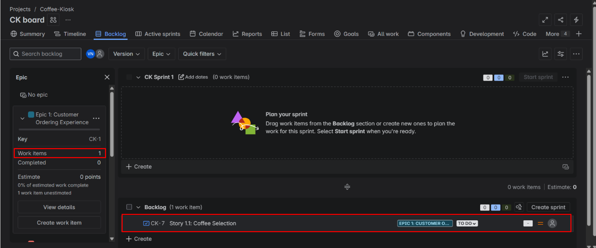

- Create all the user stories respective to their Epics and populate the backlog. Click on any Epic and the User Stories to those Epics are shown in the backlog, making it easier to view common User Stories under an Epic. 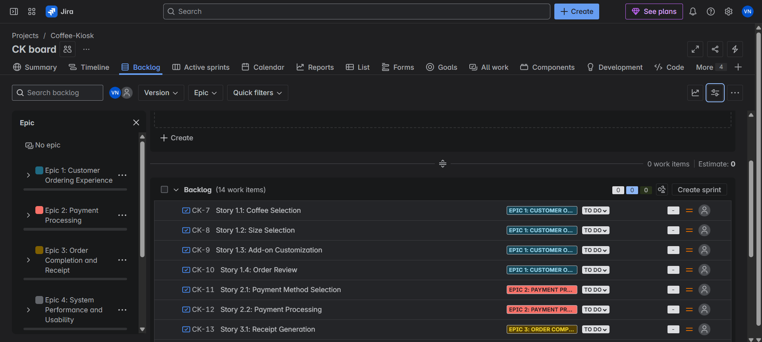
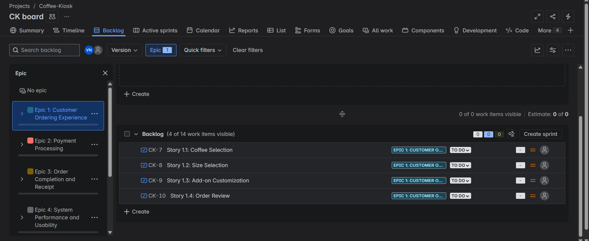

- You can change the Priority status of tasks, by default to each User Story is set to Medium Priority. You can even set your User Story priority task while creating the User Story as well. 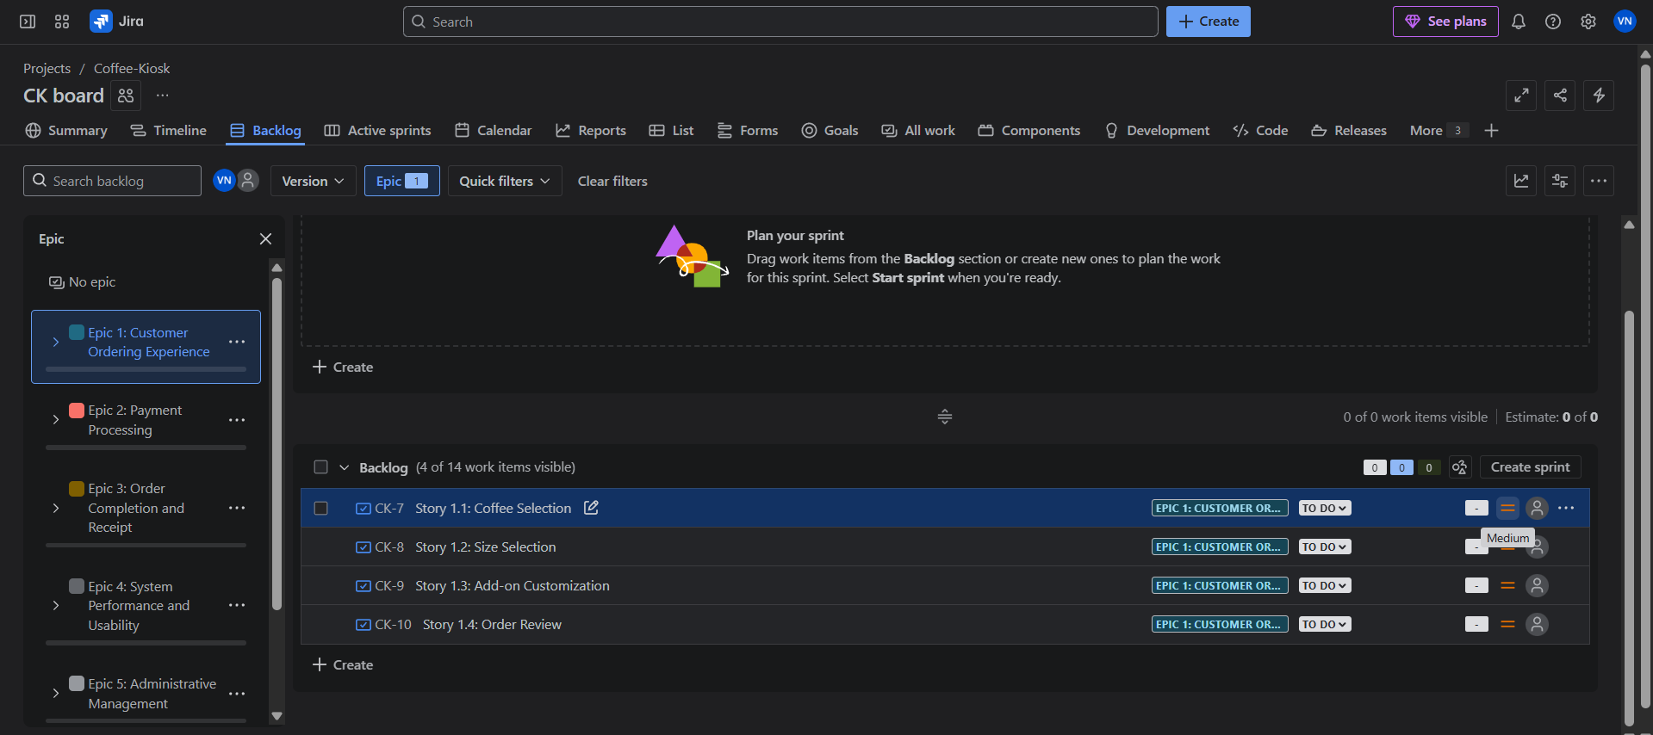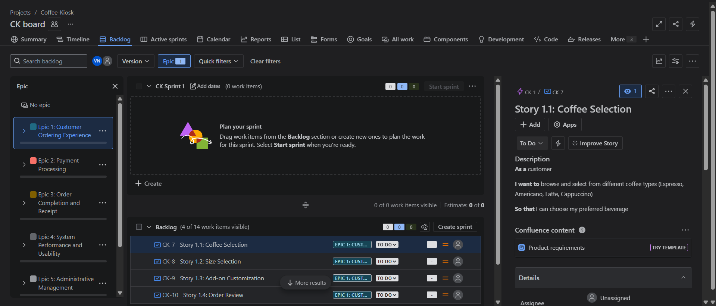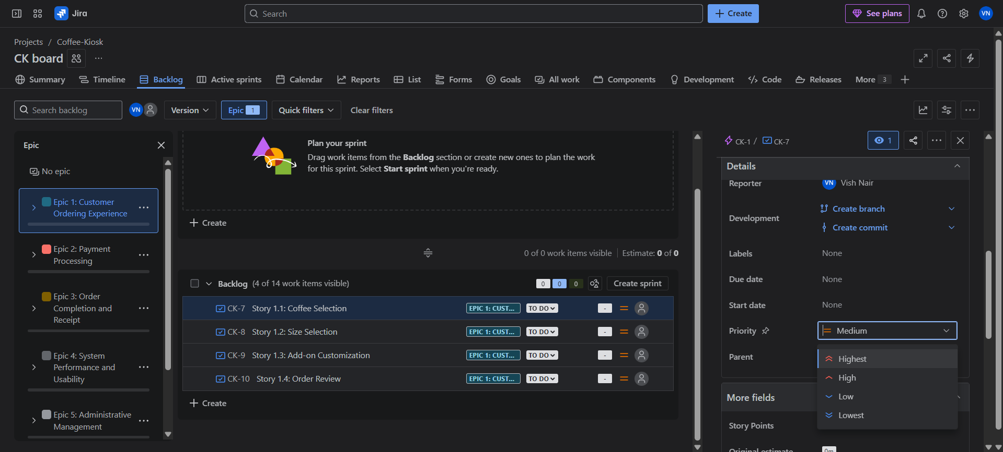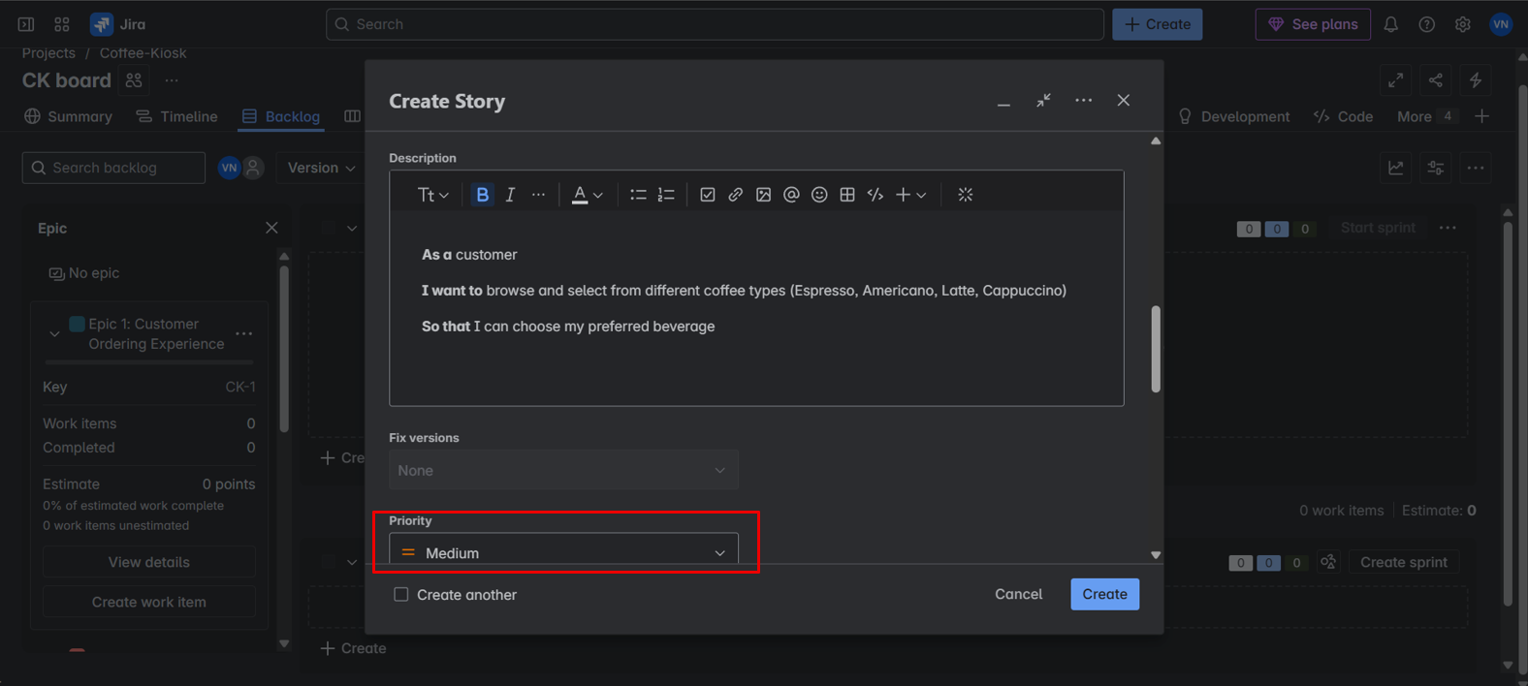

- Now assigning story points, find the More field in that you’ll find story points, based on priority. Click on the arrow next to the Epic and you’ll see the story points assigned in total for the Epic and User Stories. 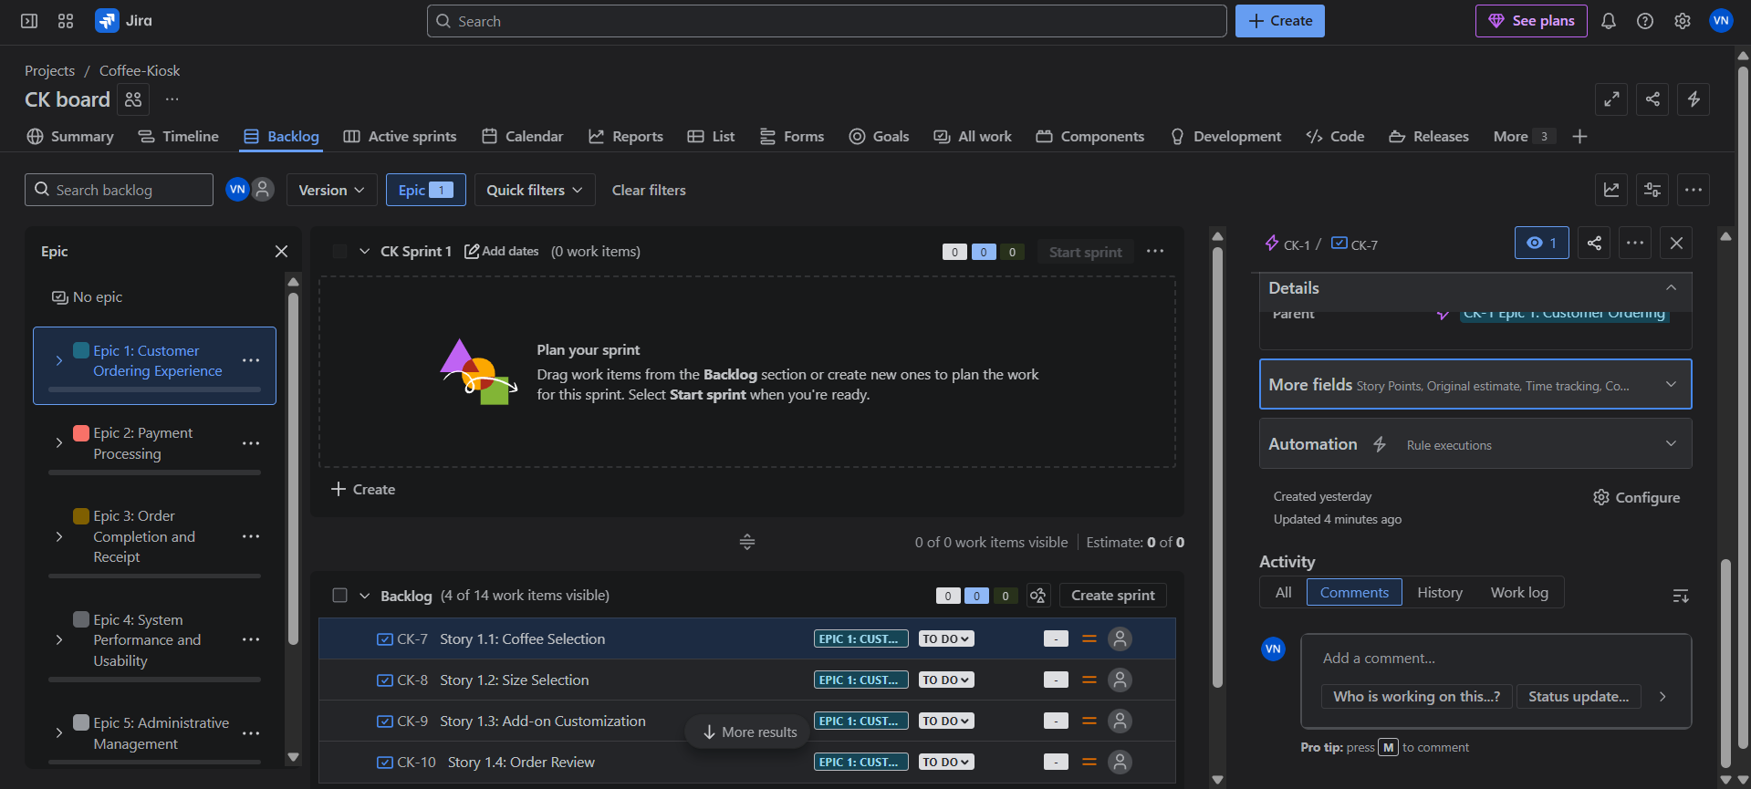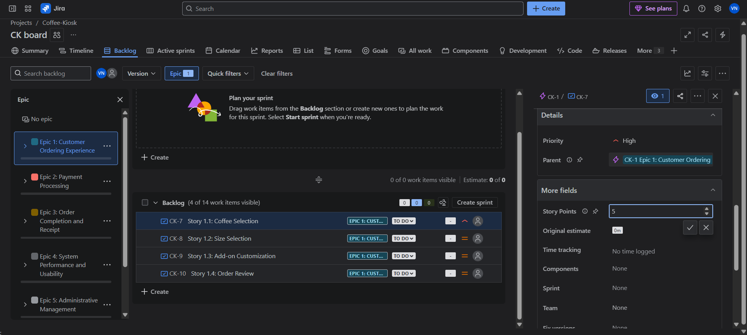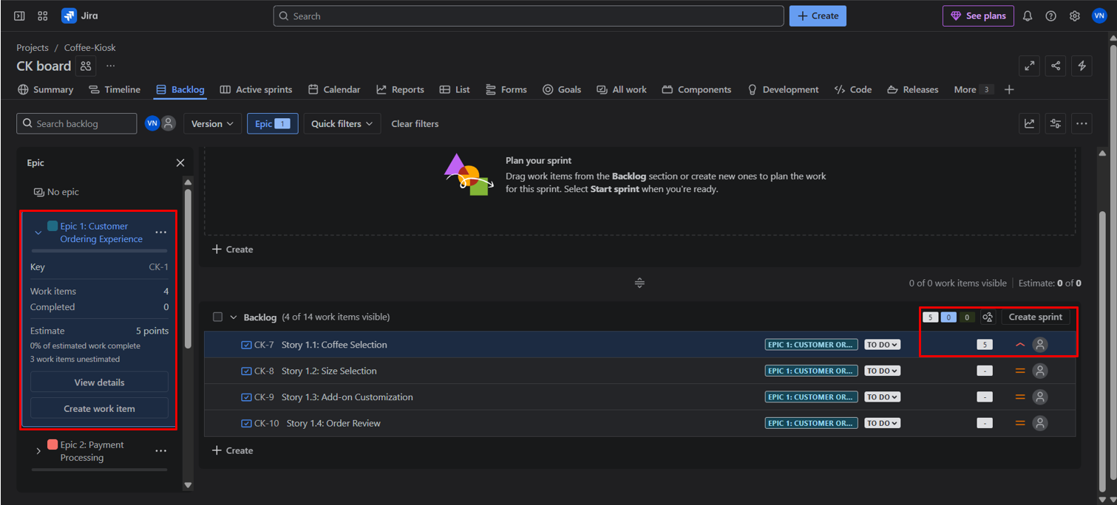

It is common practice to set priorities and assign story points for task during a discussion with the team to rank them from highest priority to the lowest.
Teams starting out with story points use an exercise called planning poker.
Planning poker is a common practice across the company. The team will take an item from the backlog, discuss it briefly, and each member will mentally formulate an estimate. Then everyone holds up a card with the number that reflects their estimate.

If everyone is in agreement, great! If not, take some time (but not too much time–just couple minutes) to understand the rationale behind different estimates. Remember though, estimation should be a high-level activity. If the team is too far into the weeds, take a breath, and up-level the discussion.

Story Points:
Story points are units of measure for expressing an estimate of the overall effort required to fully implement a product backlog item or any other piece of work. Teams assign story points relative to work complexity, the amount of work, and risk or uncertainty. Values are assigned to more effectively break down work into smaller pieces, so they can address uncertainty.
Over time, this helps teams understand how much they can achieve in a period of time and builds consensus and commitment to the solution. It may sound counter-intuitive, but this abstraction is actually helpful because it pushes the team to make tougher decisions around the difficulty of work.

An interesting fact, the story points assigned are given from the Fibonacci Series (0, 1, 2, 3, 5, 8, 13, 20, 40, 100…), why is this used?
The Fibonacci sequence is used in Planning Poker because it helps teams estimate story points more effectively, particularly for larger and more complex tasks. The sequence's inherent non-linearity reflects the increasing uncertainty associated with larger tasks, making it a useful tool for agile estimation. E.g.: - 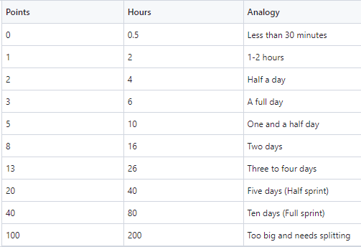
Once we have defined Epics, User Stories, prioritized them and assigned story points for all Epics and User Stories we move on to create our First Sprint.
Sprint:
A sprint is a short, time-boxed period when a scrum team works to complete a set amount of work. Sprints are at the very heart of scrum and agile methodologies, and getting sprints right will help your agile team ship better software with fewer headaches.

Sprint planning is a timeboxed event within the scrum framework that kicks off the upcoming sprint for agile teams. Sprint planning identifies what tasks will be completed in the sprint and how that work will be achieved.

In scrum , the sprint is a set period of time where all the work is done. However, before you can leap into action you have to set up the sprint. You need to decide on how long the time box is going to be, the sprint goal, and where you're going to start. The sprint planning meeting kicks off the sprint by setting the agenda and focus. If done correctly, it also creates an environment where the team is motivated, challenged, and can be successful. Bad sprint plans can derail the team by setting unrealistic expectations.

- Click the check boxes for Epic or User Stories you want to do for the Sprint. Drag and Drop them to the top where it says Sprint 1. 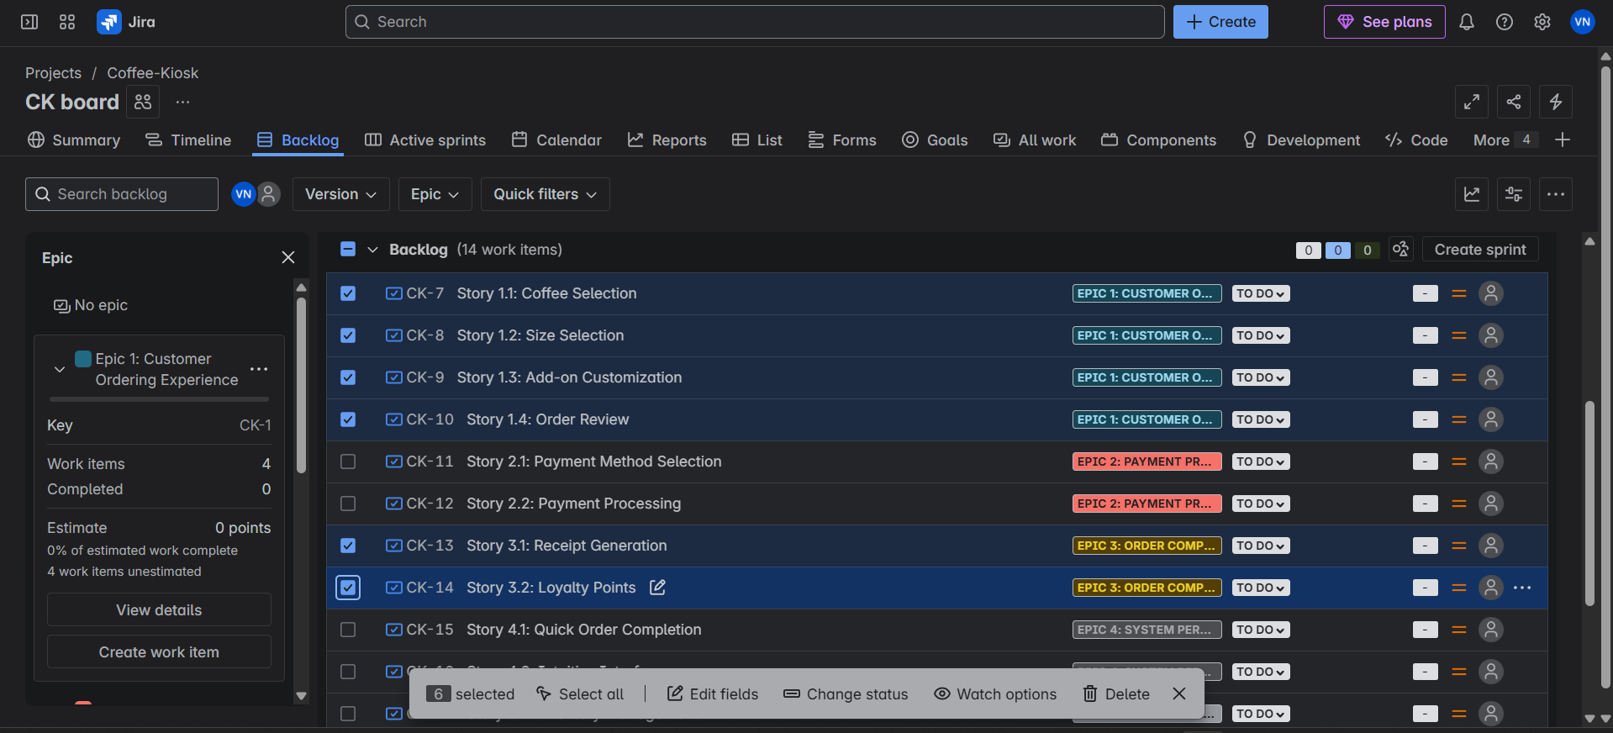
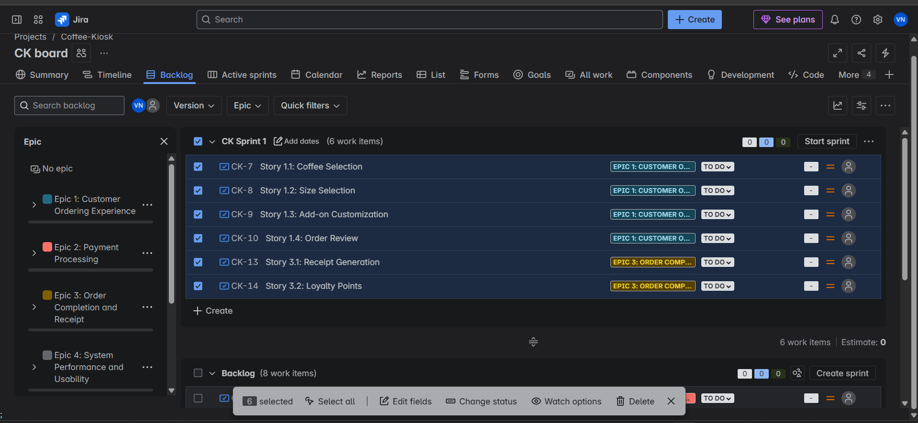

- As seen above you have now chosen or populate the tasks, user stories that need to be completed for the Sprint. Click on Start sprint. Choose the start and end date for the sprint and click on start. For this lab set 1 week as the sprint duration. 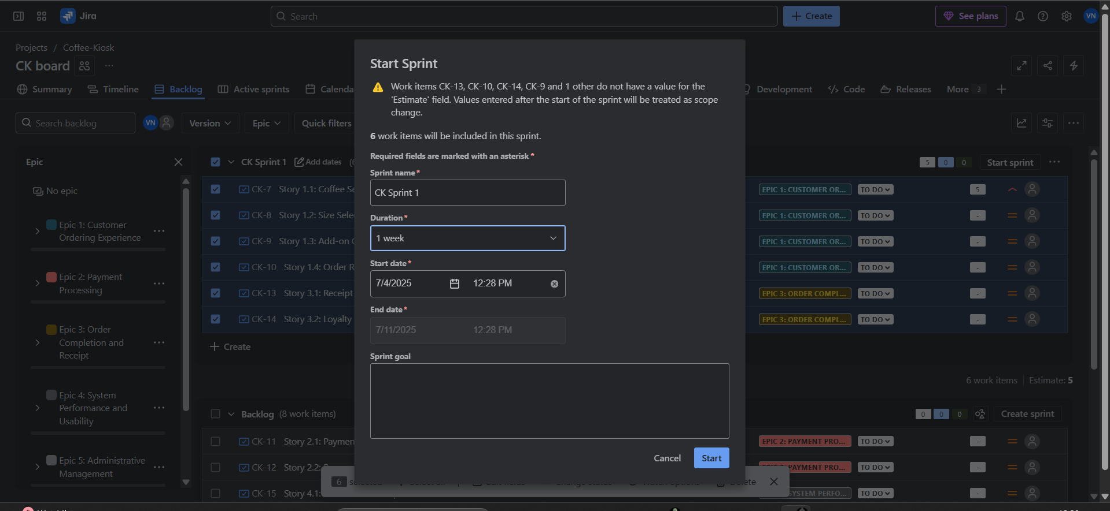

On clicking Start, it takes you to the Active sprints panel where you’ll see all the User Stories populated in the To Do column.
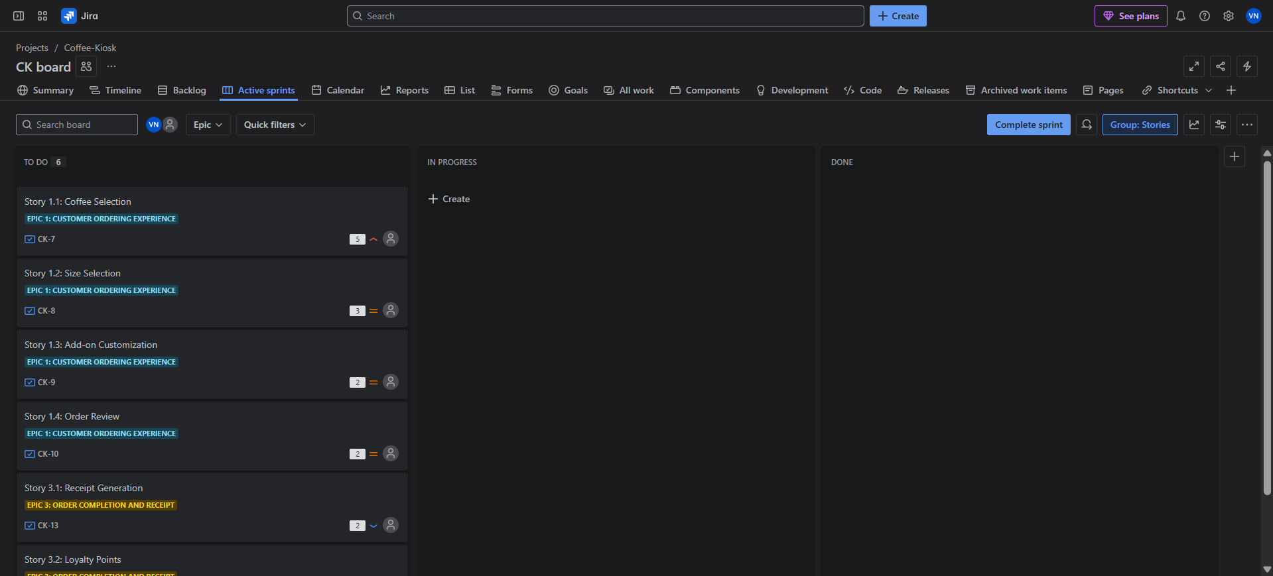
Congratulations!!!!
You have now setup your First Sprint for this Project, learned how SCRUM boards are set for projects and how AGILE-SCRUM methodology works.
You can move the User Stories from To Do to In Progress to Done, as and when the User Stories are being completed.
For this lab, since you are simulating a “Sprint” you can go ahead and move the tasks from To Do to In Progress, wait a few minutes and then move them to Done. The SCRUM Board works like a KANBAN board as well, which means you move the task in order of priority and ranking. 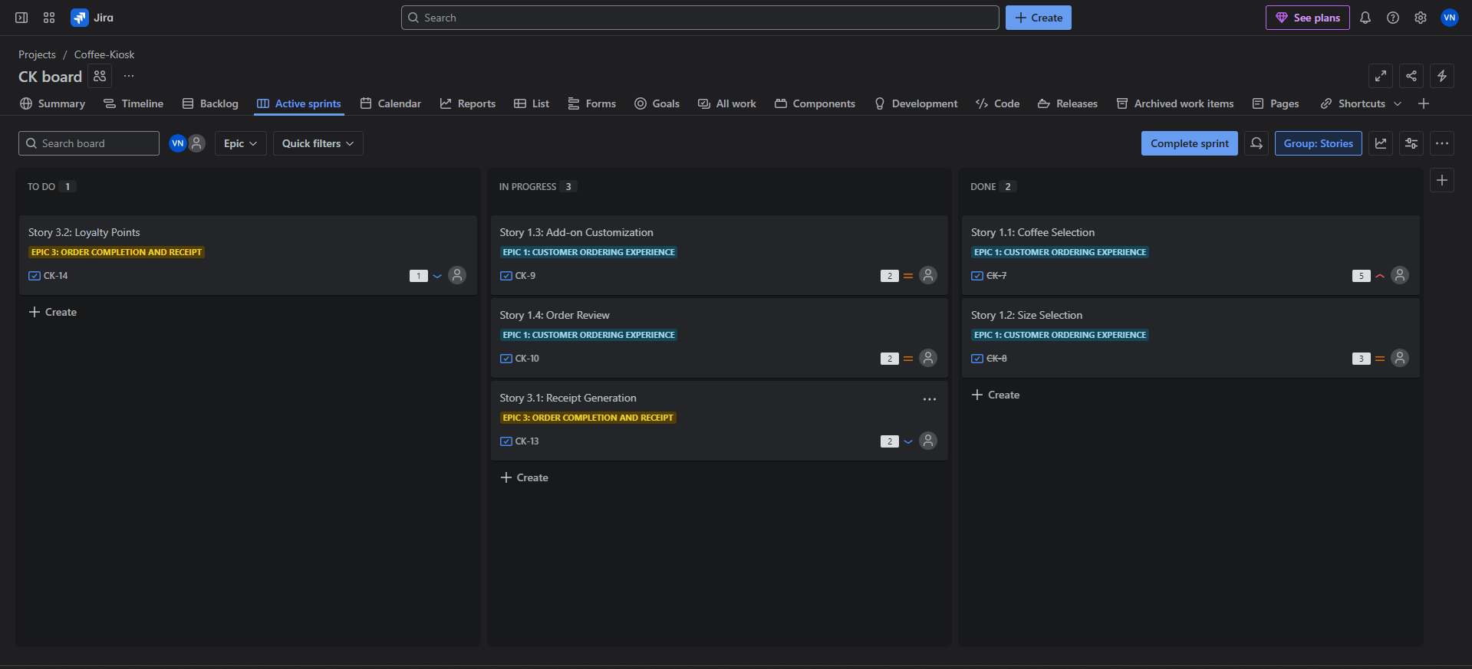
After you complete moving the User Stories from one column to the next in order of progress, click on complete sprint to end your First Sprint. 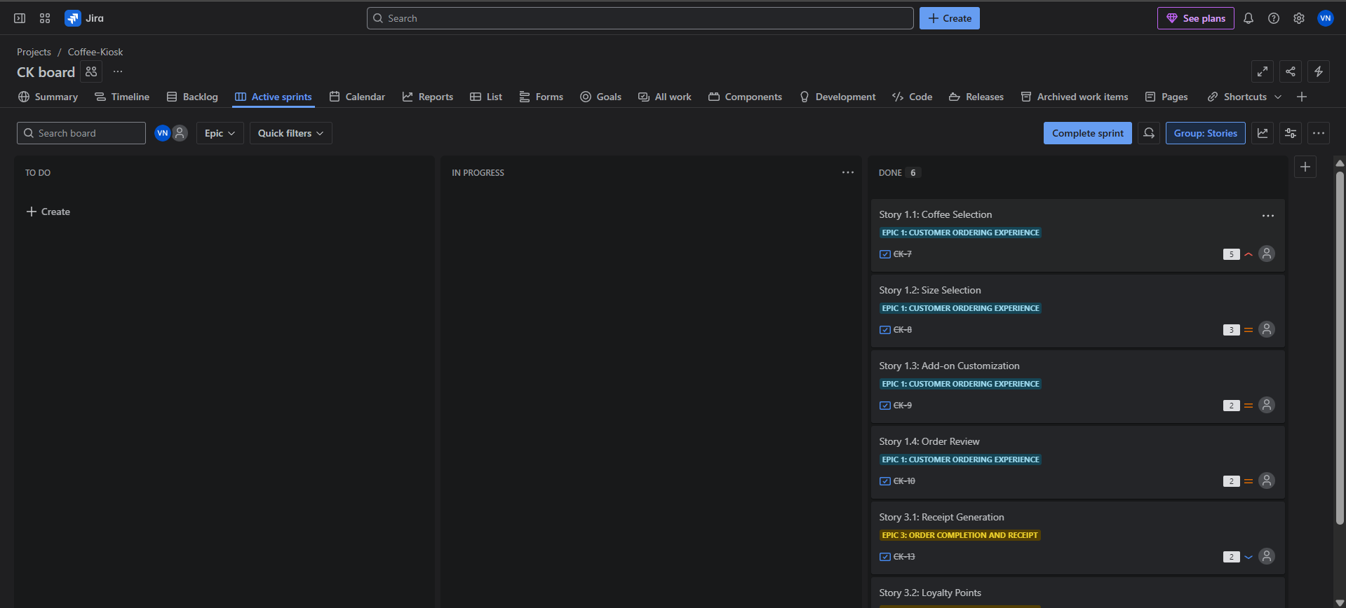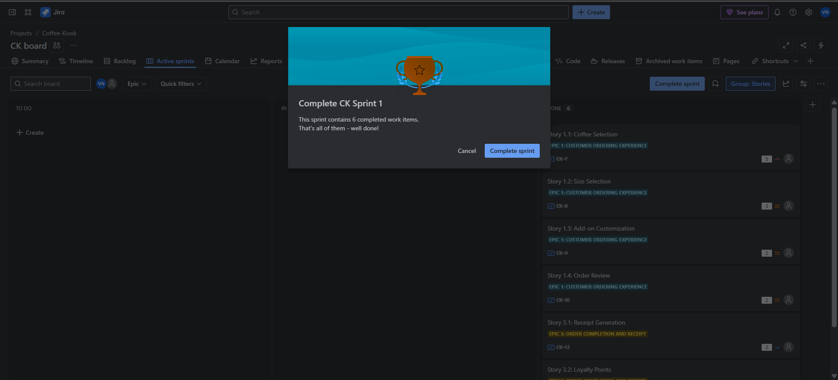
You’ll be taken back to the Backlog panel where you can go ahead and create your next Sprints as per AGILE-SCRUM methodology. 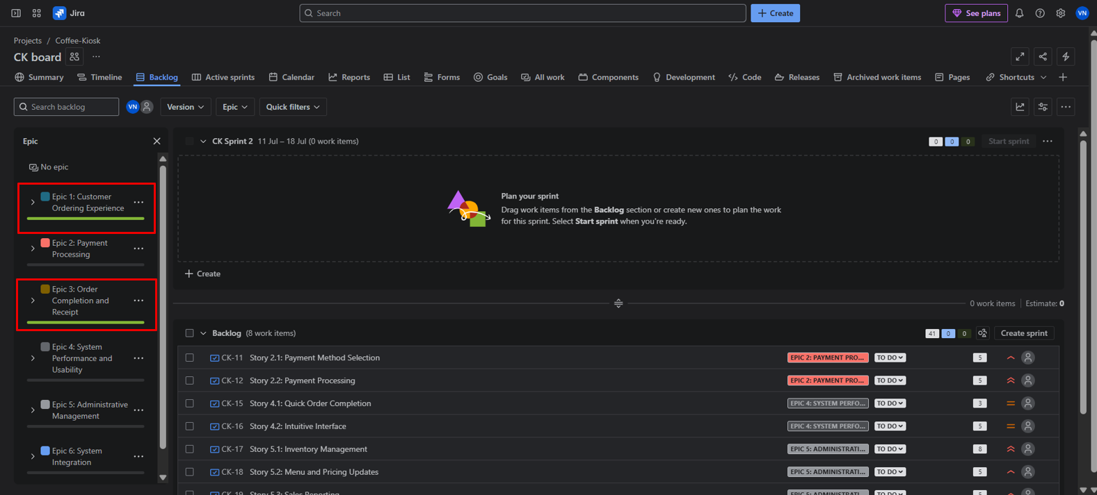
You can see the progress bars on the Epics that have been completed, if you open them and see the details, it shows the completion and total points. 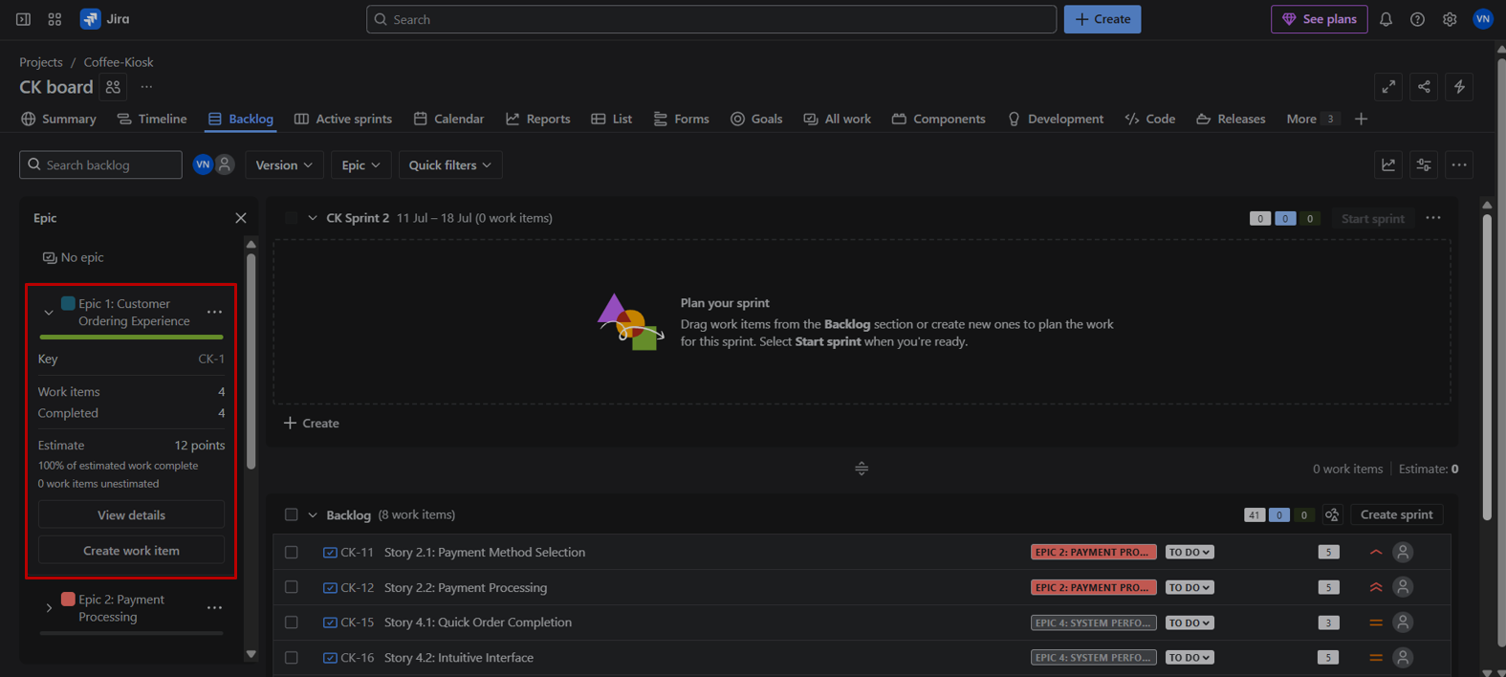
Finish 2 Sprints.
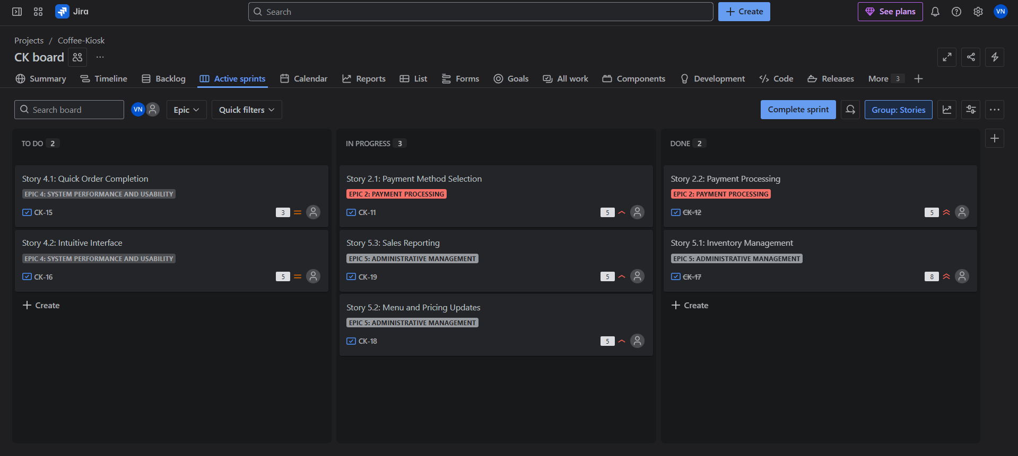

- Click on the Reports panel, next to Calendar which is next to Active Sprints. 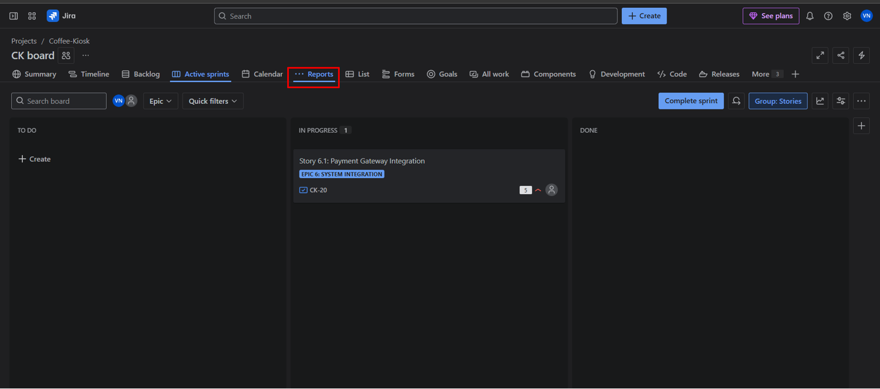

And choose the Burndown Chart. 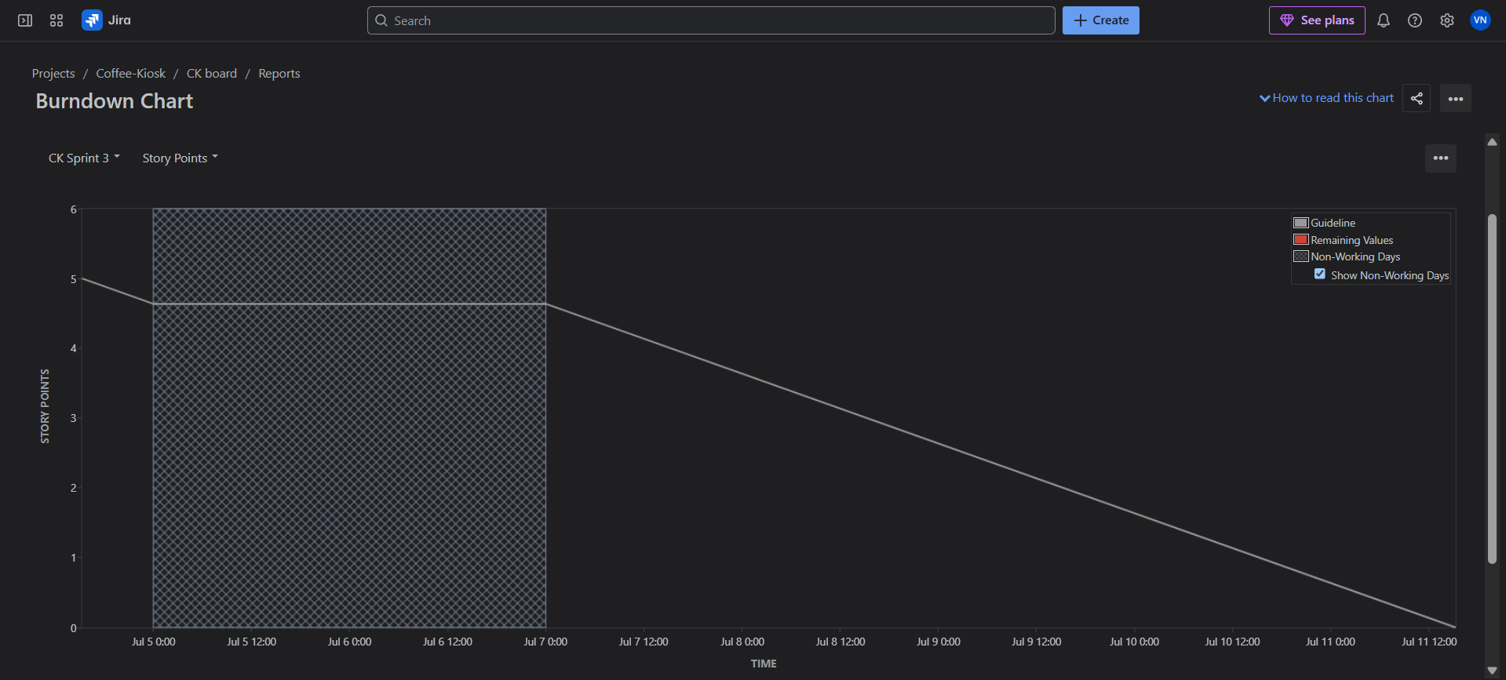

What is this Burndown Chart?
A burndown chart shows the amount of work that has been completed in an epic or sprint, and the total work remaining. Burndown charts are used to predict your team's likelihood of completing their work in the time available. They're also great for keeping the team aware of any scope creep that occurs.

Burndown charts are useful because they provide insight into how the team works. For example:
- If you notice that the team consistently finishes work early, this might be a sign that they aren't committing to enough work during sprint planning.
- If they consistently miss their forecast, this might be a sign that they've committed to too much work.
- If the burndown chart shows a sharp drop during the sprint, this might be a sign that work has not been estimated accurately, or broken down properly.

How to read this chart??
Understanding the sprint burndown chart
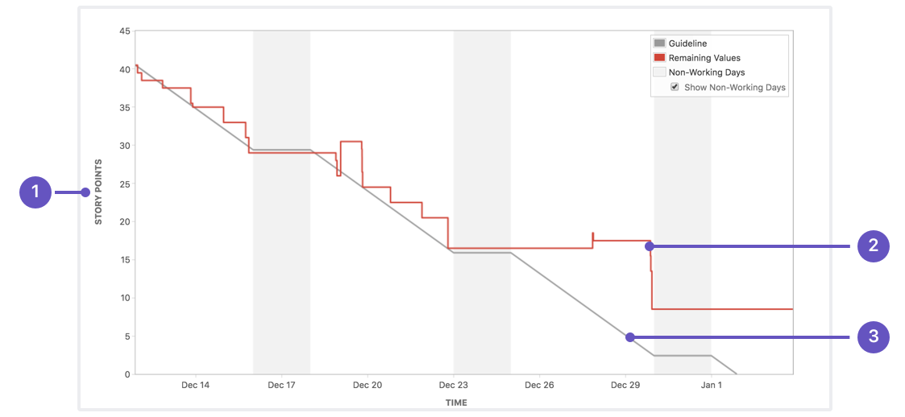
- Estimation statistic: The vertical axis represents the estimation statistic that you've selected.
- Remaining values: The red line represents the total amount of work left in the sprint, according to your team's estimates.
- Guideline: The grey line shows an approximation of where your team should be, assuming linear progress. If the red line is below this line, congratulations - your team's on track to completing all their work by the end of the sprint. This isn't foolproof though; it's just another piece of information to use while monitoring team progress.

Click the Sprint number and you’ll see the burndown chart for each sprint. 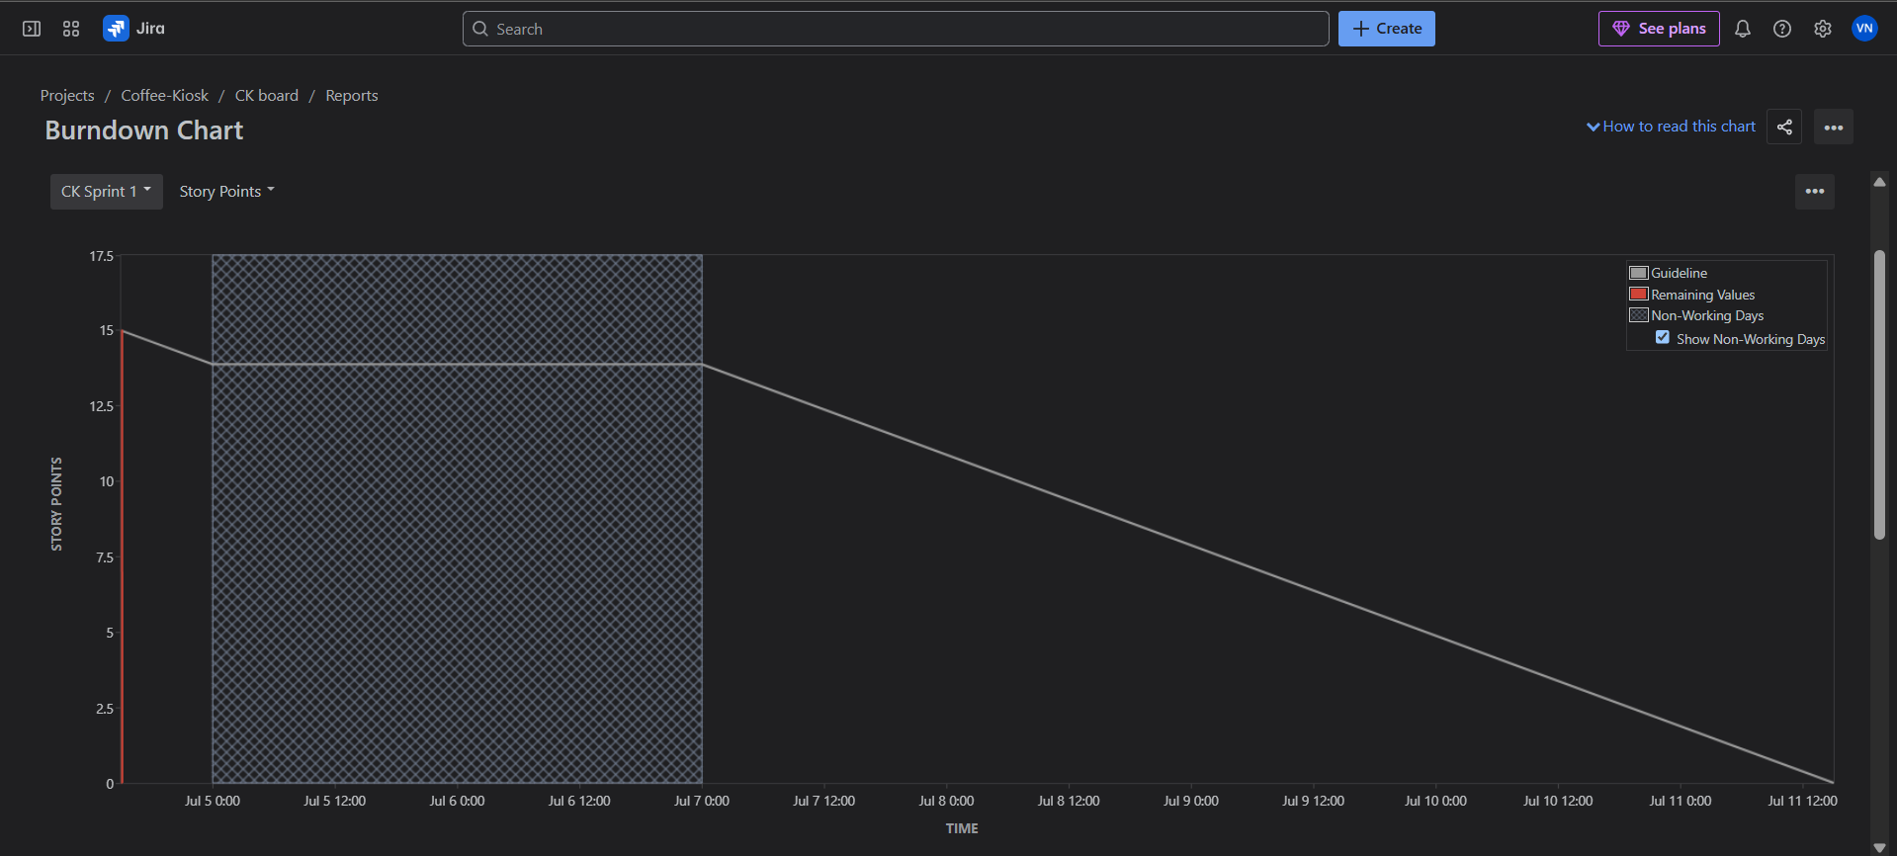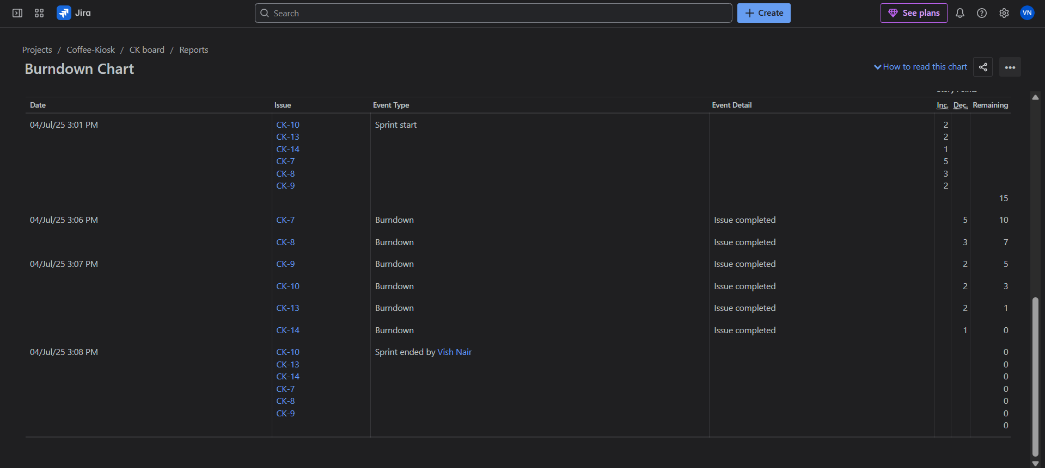
Now to see the summary and work completed you can go back to the SCRUM Board. And click on the Summary panel. 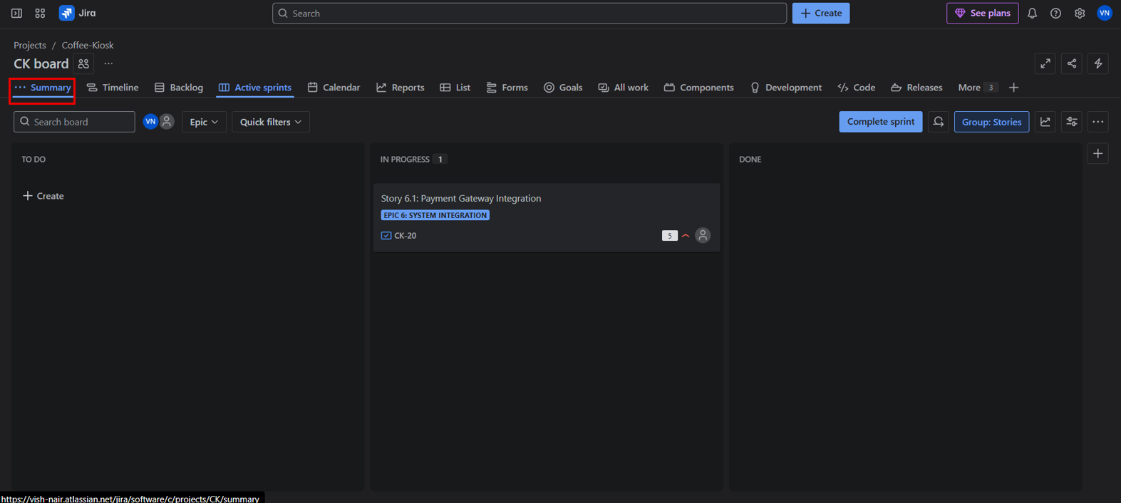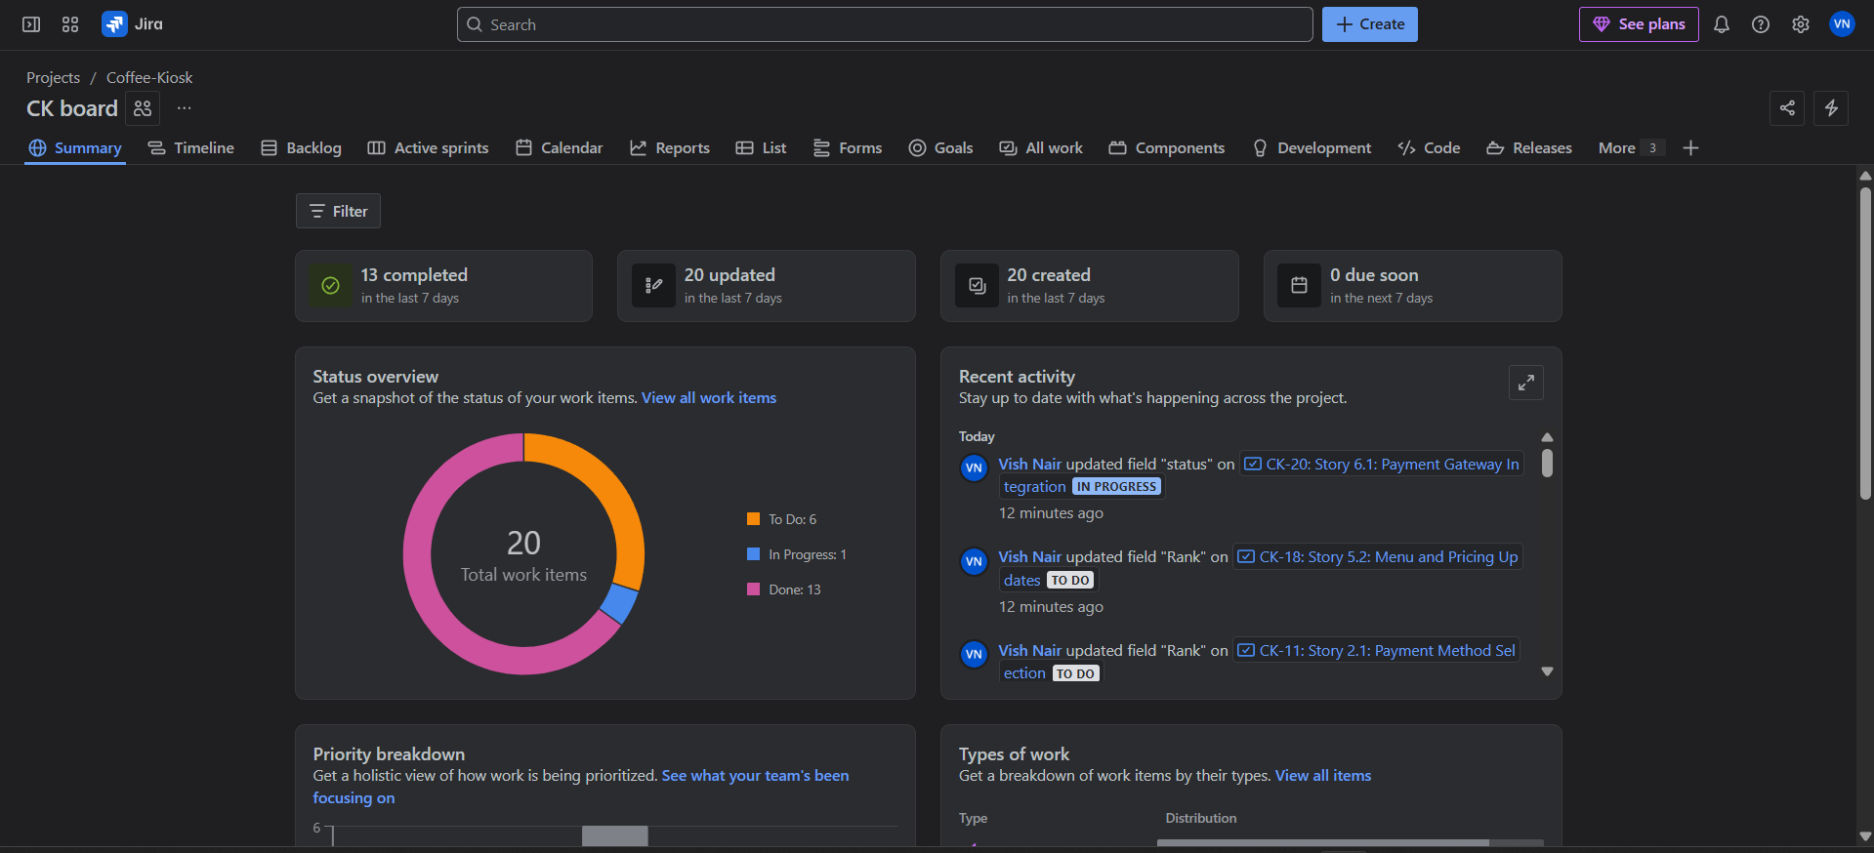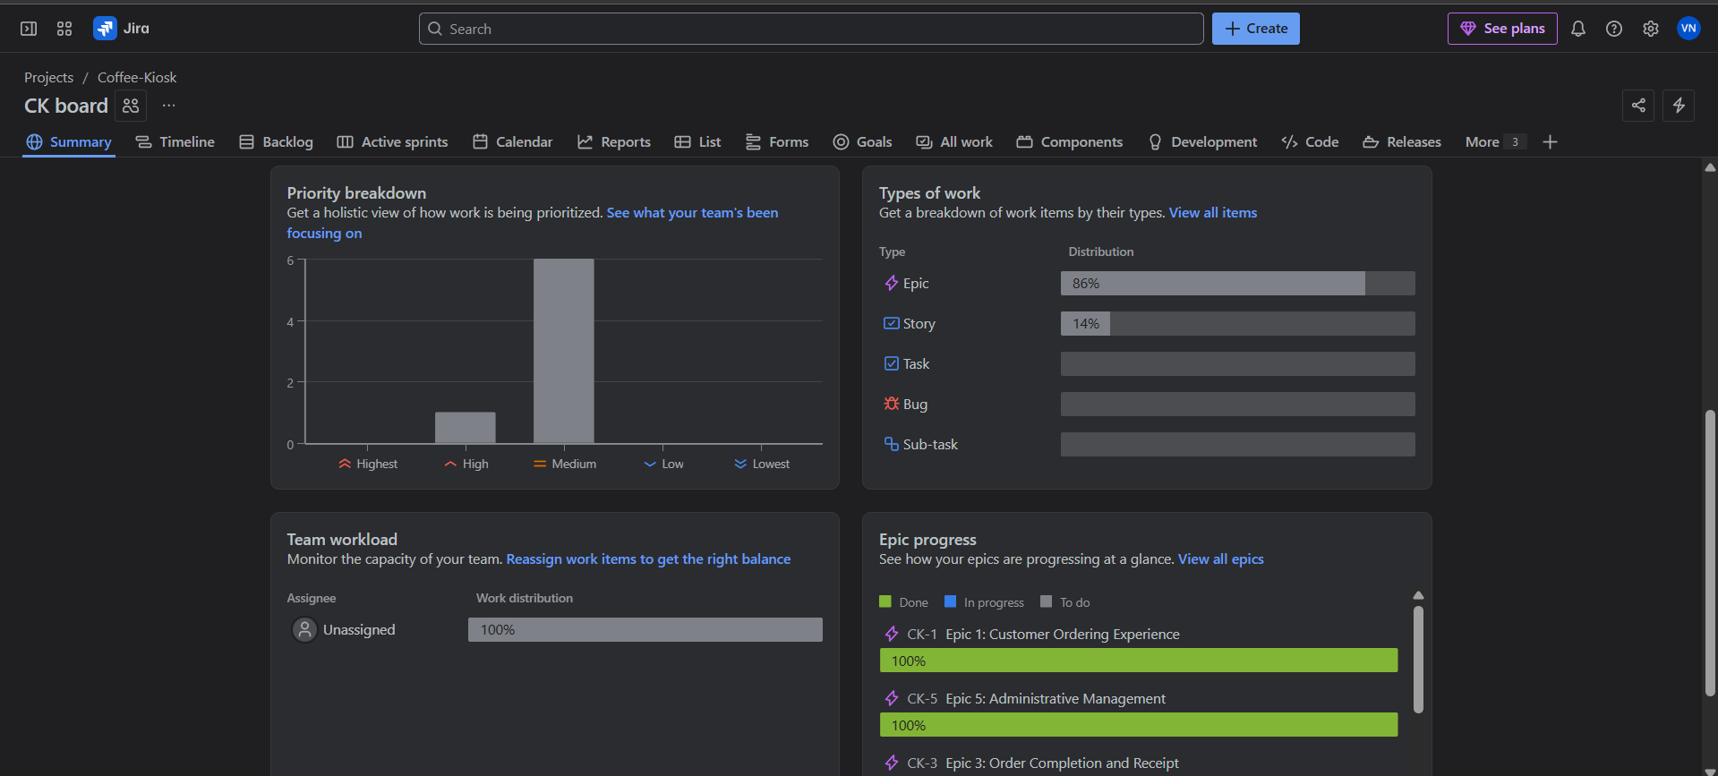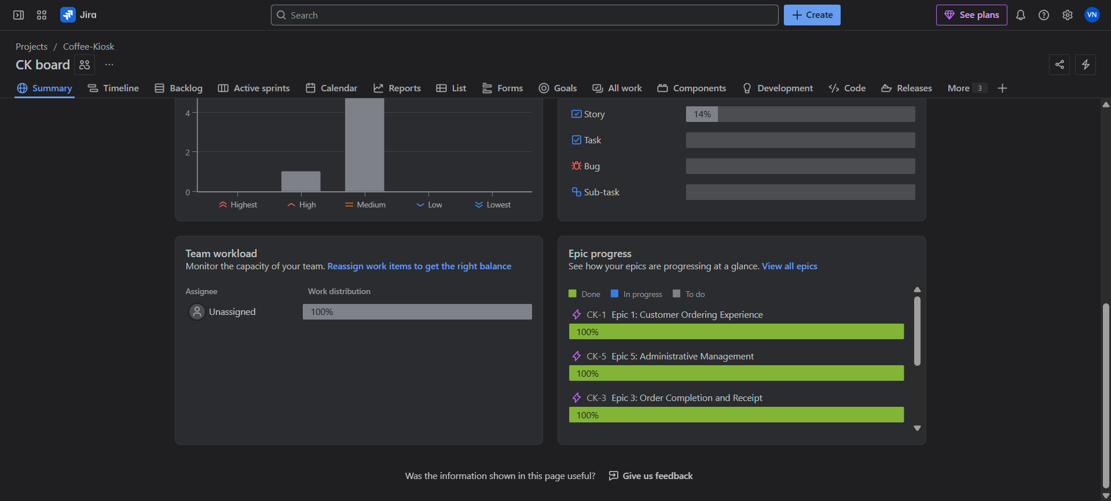

Additional Info:
If you have a team, you can assign user stories or epics to each of them. Click on the User story you want to assign, and on the right-side panel you will see “Assignee”, you can assign to yourself or to someone on your team. 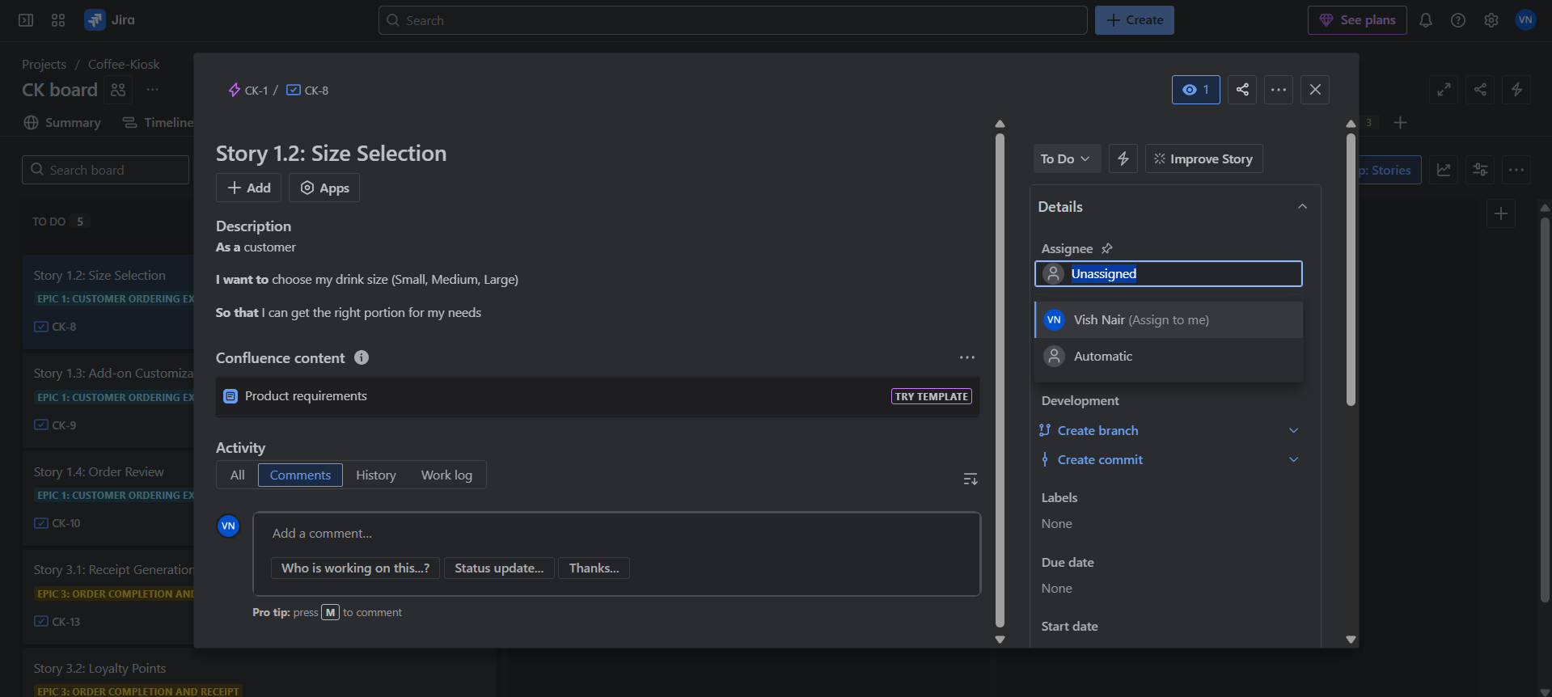

Evaluation Criteria | Marks
- Create Stories in Jira  - Assign Story Points  - Planning Poker Introduction  - Prioritize & Rank Backlog  - Set Priority for each story in Jira  - Reorder Backlog  - Run a Mock Sprint  - Create Sprint 1  - Simulate Progress  - Add Comments  - Generate Burndown Chart.  - Group Reflection. | 4 marks  3 marks  2 marks  3 marks  1 mark  2 marks

